Hamilton County

Re-Entry Program
Resource Directory

Table of Contents

Local & National Helplines
Help Finding Resources
Alcohol / Drug Abuse Help
Child Care
Child Support
Clothing Assistance
Domestic Violence Services
Education & Training
Homeless Shelters
Employment
Financial Assistance & Money Management
Food Assistance
Food Pantries
Health Services
Housing Needs
Legal Aid and Tax
Legal Matters
Library
Medication Assisted Treatment
Mental Health & Counseling
Nutritional Information
Parenting Resources
Recovery Housing / Residential Treatment Programs
Special Needs Help for Children
Support Group Services
Transportation
Recreational Activities

4

8

11

16

19

20

23

24

29

33

36

41

44

47

58

62

63

66

67

70

74

76

81

85

88

91

92
LOCAL & NATIONAL HELPLINES

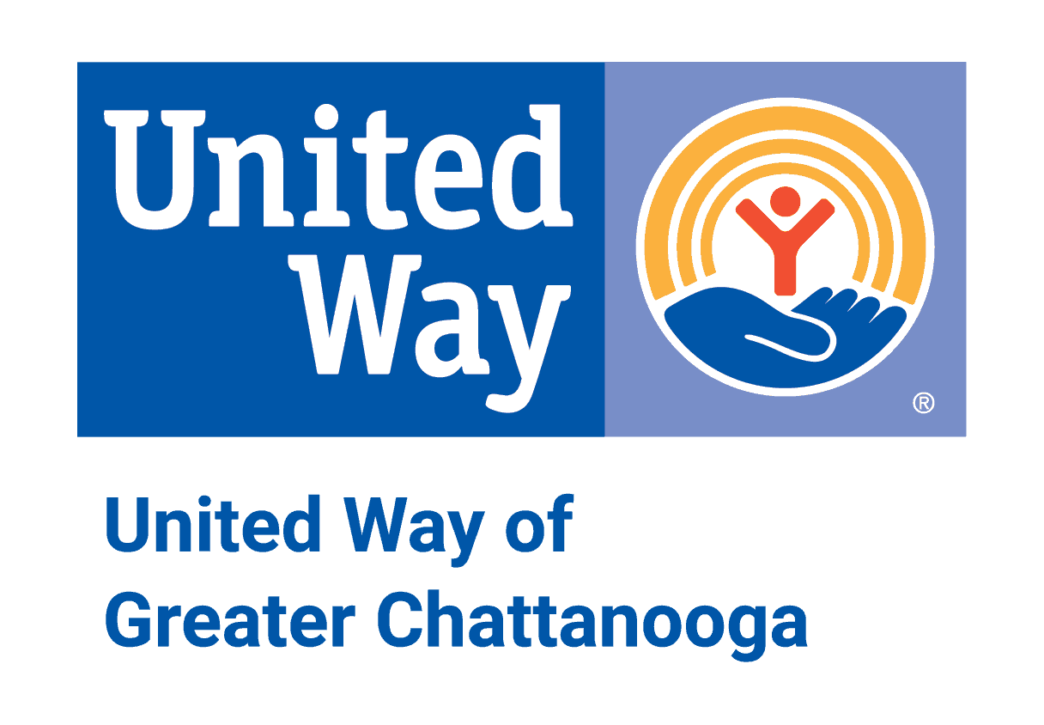
2-1-1
If you live in Hamilton County, dial 211 for emergency assistance or call (423) 265-8000.
Toll Free: 1-866-921-3035
Hours: Monday - Friday 8:30am-5:00pm
Text your zip code to 898-211 to start chat

Alcoholics Anonymous
Address: 5611 Ringgold Rd. Suite 130 Chattanooga, TN 37412
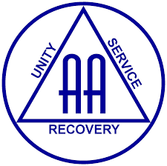
Phone Number: 423-499-6003
Website: https://chattanooga-aa.com/
Email: chattcentraloffice@gmail.com
Hours: Monday - Friday 9:00am – 5:00pm; Saturday 9:00am – 1:00pm (call first)
24-Hour hotline and information about meetings.

Alcoholics Anonymous is a fellowship of men and women who share their experience, strength and hope with each other that they may solve their common problem and help others to recover from alcoholism.

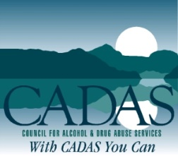
CADAS (Center for Alcohol and Drug Abuse Services)
Address: 207 Spears Ave. Chattanooga, TN 37405
Phone Number: 423-756-7644
Website: www.cadas.org
Hours: Monday - Friday 8:05am – 5:00pm

Chattanooga Area Local Crisis Line
Phone Number: 1-800-704-2651

Crisis services are available 24/7 to respond to adults experiencing a mental health crisis. Offers information and crisis phone counseling, face to face crisis evaluation, triage and referrals by mobile crisis teams. Crisis Walk-in Centers are available in Chattanooga and Cookeville.

Child Abuse/Neglect 24 Hour Hotline
Phone Number: 877-237-0004
Website: tn.gov/report-child-abuse.org

The Tennessee Child Abuse Hotline accepts all reports of suspected child abuse and neglect for the state of Tennessee. The Tennessee Child Abuse Hotline is open 365 days a year, 24 hours a day and 7 days a week.

Hamilton County APS (Adult Protective Services)
Address: 311 E MLK Blvd. Chattanooga, TN 37403
Phone Number: 423-355-3329
Hours: Mon-Fri 8:00am – 4:30pm

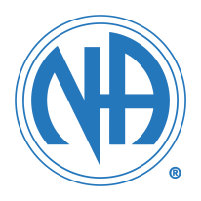
Narcotics Anonymous
Phone Number: 1-888-463-2117 (24-Hour Helpline)
Website: www.nachattanooga.com/

Website provides printable meeting schedule for NA meetings around Chattanooga area.
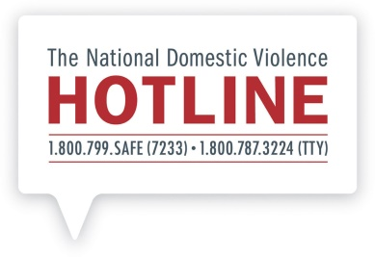

National Domestic Violence Hotline
Phone Number: 800-799-7233 (1-800-799-SAFE)
Website: http://www.thehotline.org/

Tennessee Domestic Violence Hotline
Phone Number: 1-800-356-6767

The Hotline’s highly-trained advocates are available 24/7 to talk confidentially with anyone experiencing domestic violence, seeking resources or information, or questioning unhealthy aspects of their relationship.
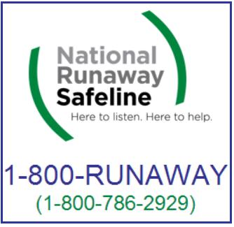

National Runaway Safeline
Phone Number: 1-800-786-2929 (1-800-RUNAWAY)
Website: www.1800runaway.org / Text 66008


National Sexual Assault Hotline
Phone Number: 1-800-656-4673

RAINN (Rape, Abuse & Incest National Network) is the nation’s largest anti-sexual violence organization. RAINN created and operates the National Sexual Assault Hotline. Available 24/7, here to help YOU.
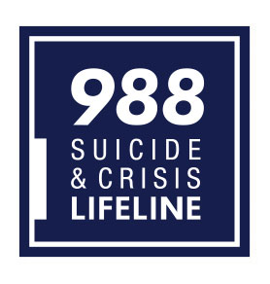

National Suicide Prevention Lifeline
Phone Number: 988
Website: Suicidepreventionlifeline.org
The Lifeline provides 24/7, free and confidential support for people in distress, prevention and crisis resources for you or your loved ones, and best practices for professionals.
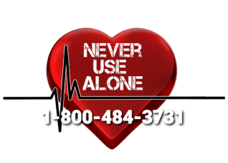
Never Use Alone

Phone Number: 1-800-484-3731

If you are going to use by yourself, call us! You will be asked for your first name, location, and the number you are calling from. An operator will stay on the line with you while you use. If you stop responding after using, the operator will notify emergency services of an “unresponsive person” at your location.

Chattanooga Area Local Domestic Violence & Sexual Assault Crisis Hotline

Phone Number: 423-755-2700 (Available 24/7)

Victim support services seek to stop the cycle of violence by providing the tools and resources for individuals and families to move forward after traumatic experiences such as sexual assault, domestic violence and human trafficking. Victims are transformed into survivors through 24/7 emergency help as well as ongoing support during recovery.

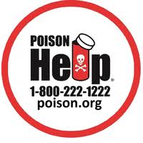
Poison Control
Phone Number: 1-800-222-1222 / Text POISON to 797979
Website: www.aapcc.org
Website: https://poisonhelp.org/help

TennCare Member Services
Phone Number: 1-800-342-3145

TN Department of Human Services Child Care Complaints
Phone Number: 1-800-462-8261

In the state of Tennessee, to report suspected licensing violations or possible illegal child care operations, call the Child Care Complaint Hotline.

Tennessee Adult Protective Services

Phone Number: 1-888-APS-TENN (1-888-277-8366)
Website: https://reportadultabuse.dhs.tn.gov/


Tennessee REDLINE

Phone Number: 1-800-889-9789

For immediate help and information on treatment, contact the Tennessee Redline. The TN Redline provides accurate, up-to-date alcohol, drug, problem gambling, and other addiction information and referrals. Free, 24/7 confidential referrals to addiction treatment.

Tennessee Coalition to End Domestic & Sexual Violence

Hotline: 1-800-356-6767
Website: https://www.tncoalition.org/

Tennessee Human Trafficking Hotline

Phone Number: 855-558-6484 (1-855-55-TNHTH)

National Human Trafficking Hotline

Phone Number: 1-888-373-7888 / Text “HELP” or “INFO” to 233733


Tennessee Statewide Crisis Hotline
Call 855-CRISIS-1 (855-274-7471)

The statewide crisis line is a 24/7/365 call system to help anyone experiencing a mental health crisis.

Website: www.crisistextline.org / Text 741741

HELP FINDING RESOURCES

2-1-1
If you live in Hamilton County, dial 211 for emergency assistance or call (423) 265-8000.
Toll Free: 1-866-921-3035
Hours: Monday - Friday 8:30am-5:00pm
Text your zip code to 898-211 to start chat

2-1-1 is a free and confidential service helping people across the Tennessee Valley find the local resources they need when they need them. One call to 2-1-1 connects you to someone who can help you navigate the maze of human services to get you to the help you need. 2-1-1 offers information about food, housing, employment, transportation, health services, eldercare, and other crisis hotlines. Their trained information and referral specialists can help you find resources for all of these needs and more. Simply dial 2-1-1 and stay on the line to speak with an information and referral specialist about your needs.

Chattanooga Autism Center
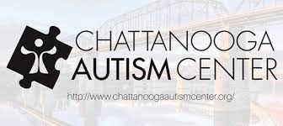
Address: 1400 McCallie Ave. Suite 100 Chattanooga, TN 37404
Phone Number: 423-531-6961
Website: www.chattanoogaautismcenter.org
Hours: Monday - Friday 9am – 4pm

Non-profit parent-driven center providing lifespan support and services for people with autism spectrum disorders and their families.

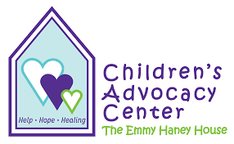
Children’s Advocacy Center of Hamilton County
Address: 5705 Uptain Rd. Suite C Chattanooga, TN 37411
Phone Number: 423-266-6918
Website: www.cachc.org
Hours: Monday – Friday 8am – 5pm

The Children’s Advocacy Center is dedicated to providing a coordinated and comprehensive path to healing for children who have experienced child sexual abuse or severe physical abuse, and engages the community in education initiatives.

The CAC facilitates the teamwork essential for effective intervention and healing in one location where all professionals and agencies responsible for investigating and providing services can provide a coordinated response on a child's developmentally appropriate level.

District Attorney Offices (Victims Witness Assistance)
Address: 600 Market St. Chattanooga, TN 37402
Phone Number: 423-209-7400
Website: www.chattanoogada.com

Our Victim/Witness Coordinators are here to support you and to answer your questions. In addition to helping you understand the criminal justice system, they will provide you with status updates on your case and can also make referrals to other services that may be available to you.

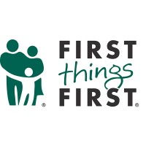
First Things First
Address: 620 Lindsey St. Suite 100 Chattanooga, TN 37403
Phone Number: 423-267-5383
Website: www.firstthings.org
Hours: Monday – Friday 8:30am – 5:00pm

They are a non-profit that provides valuable, affordable relationship resources to all. From teens to seriously dating and engaged couples, to married couples and parents, to all of the relationship dynamics found in a workplace environment, we provide the relationship tools you need in almost every season of life.

Hamilton County Emergency Services
Address: 317 Oak St. Suite 302 Chattanooga, TN 37403
Phone Number: 423-209-6900
Website: www.hamiltontn.gov/emergencyservices/


HOPE for the Inner City
Address: 1800 Roanoke Ave. Chattanooga, TN 37406
Phone Number: 423-698-3178
Website: www.hopefortheinnercity.org
Hours: Monday 11:00am – 2:00pm;
Tuesday – Friday 9:00am – 2:00pm

Hope for the Inner City is a Christian organization that engages, invests in, and empowers our neighbors to bring economic stability to their community for the glory of God, beginning with East Chattanooga.
Mercy Relief
Hope for the Inner City provides financial and in-kind assistance to their neighbors in the 37404 and 37406 zip codes who need immediate help with rent, utilities, clothing and home repairs. If we cannot help immediately, we partner with other organizations who can.

Food Assistance
They maintain a pantry, stocked with non-perishable items, for their 37404 and 37406 neighbors in need of food assistance. The pantry is open Monday through Friday from 8am to 5pm, and they are also able to deliver to your home. To apply for food assistance, please visit them at the Hope office.

Dental Clinic
We run a dental clinic to affordably meet the oral health needs of the community. Local, volunteer dentists and oral surgeons open our clinic weekly for dental care and to share informational resources. If you need an appointment, click here, please visit us at the Hope office.


La Paz
Address: 1402 Bailey Ave. Chattanooga, TN 37404
Phone Number: 423-624-8414
Website: www.lapazchattanooga.org
Hours: Monday - Friday 9am – 4pm

The mission of La Paz is to empower and engage Chattanooga’s Latinx population. They have a vision of a thriving Latinx community. They support efforts that are designed to make Chattanooga a more inclusive city.
Eligibility: Everybody is eligible.
Payment Information: Free of charge

ALCOHOL AND DRUG ABUSE HELP

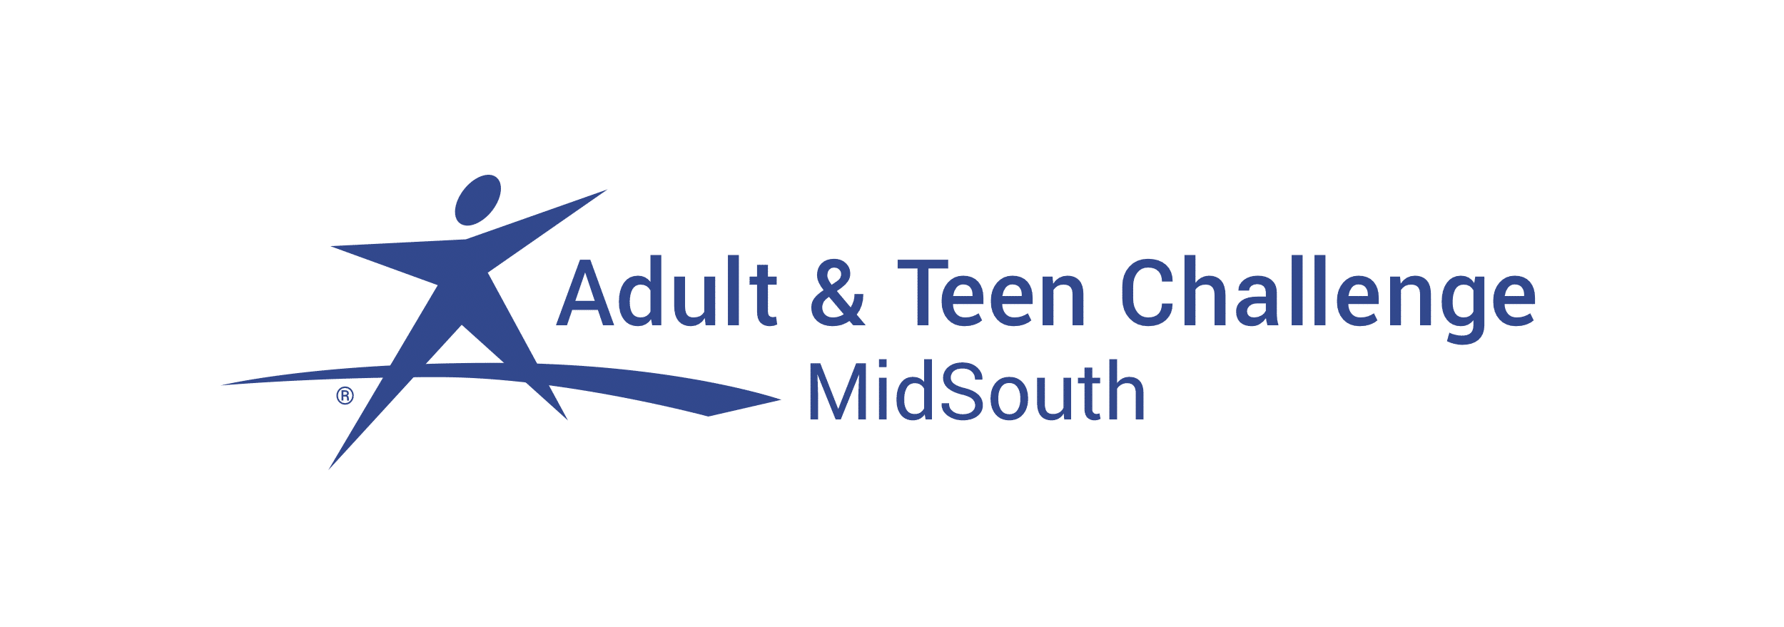
Adult & Teen Challenge of the Mid-South (Residential Treatment)
Address: 1108 W 33rd St. Chattanooga, TN 37410
Phone Number: 423-756-5558
Hours: Monday - Friday 8:00am – 4:00pm

Our mission is to help provide men & women (18-50) freedom from addiction and other life-controlling issues through Christ-centered solutions. The Adult & Teen Challenge MidSouth center strives to accomplish that mission by empowering, educating, and equipping the residents on our campus.

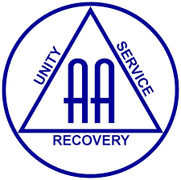
Alcoholics Anonymous Chattanooga Area Central Office
Address: 5611 Ringgold Rd. Suite 130 Chattanooga, TN 37412
Phone Number: 423-499-6003
Email: chattcentraloffice@gmail.com
Website: www.chattanooga-aa.com
Hours: Monday - Friday 9:00am – 5:00pm Sat 9:00am – 1:00pm

Alcoholics Anonymous is a fellowship of men and women who share their experience, strength and hope with each other that they may solve their common problem and help others to recover from alcoholism.


Bradford Health Services (Intensive Outpatient Services)
Address: 6160 Shallowford Rd. Suite 103 Chattanooga, TN 37421
Phone Number: 423-892-2639 or 423-933-2685
24/7 Crisis: 423-322-4032
Website: www.bradfordhealth.com
Bradford Health Services is a community resource agency that provides free consults 24/7 and specializes in treating drug/alcohol addiction in adolescents and adults through in/out patient services. Bradford Health accepts nearly all commercial insurance: TennCare, Bluecare, and Private Pay. Consults are free.

CADAS (Center for Alcohol and Drug Abuse Services)
Residential and IOP (*financial assistance available)
Address: 314 Spears Ave. Chattanooga, TN 37405
Phone Number: 423-756-7644 or 1-877-AT-CADAS
Website: www.cadas.org
Hours: Monday - Friday 8:00am – 5:00pm

CADAS provides a full continuum of services for adolescents and adults with substance abuse and/or co-occurring disorders. CADAS offers Medical Detoxification for adults, Residential Services, Partial Hospitalization & Intensive Outpatient for adolescents and adults. CADAS also offers transitional living services for adults including specific programming for women & children and Prevention Services, DUI School, and Drug Testing Services as requested. Most private insurance and TennCare accepted & services offered to those without insurance meeting the criteria.

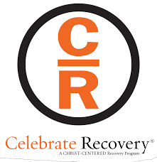
Celebrate Recovery
Phone Number: 423-309-4524
Email: cljscuba@gmail.com
Website: www.celebraterecovery.com
Celebrate Recovery is a Christ-centered, 12 step recovery program for anyone struggling with hurt, pain or addiction of any kind.

Celebrate Recovery is a safe place to find community and freedom from the issues that are controlling our life.

Chattanooga Recovery Center (Partial Hospitalization Program, IOP, Nighttime Outpatient Treatment Program, MAT)
Address: 13 W. Kent St. Chattanooga, TN 37405
Phone Number: 423-210-4754
Email:
Website: www.chattanoogarecoverycenter.com
Hours:
Chattanooga Recovery Center is dedicated to helping anyone suffering from mental health, trauma, & addiction reclaim their life through an individualized and fully transparent treatment plan.

They accept major insurance companies. They provide help through Adventure-Based Counseling, Brainmapping, Trauma Intervention Model and Equine Therapy.


Cumberland Heights (Residential and IOP)
Address: 6650 East Brainerd Rd. Suite 102 Chattanooga, TN 37421
Phone Number: 423-308-0689 or 800-646-9998
Admissions Number: 866-899-5501
Website: www.cumberlandheights.org

Their treatment programs encompass the physical, mental, emotional and spiritual dimensions of recovery through professional excellence, the principles of the Twelve Steps, and a safe, loving environment.

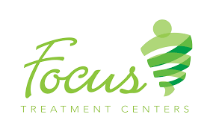
Focus Treatment Centers (Residential and IOP)
Address: 7429 Shallowford Rd. Chattanooga, TN 37421
Phone Number: 423-308-2560
Website: www.focustreatmentcenters.com/

Focus Treatment Centers offers treatment and advocacy for adults struggling with substance addictions, eating disorders, or those with dual diagnoses. Focus Treatment Centers is in network with most major insurance companies.


Hamilton County Coalition
Address: 5721 Marlin Rd. 6100 building,
Suite 3200 Chattanooga, TN 37411
Phone: 423-305-1449
Website: https://www.hccoalition.org/
Hours: Monday – Friday 10am – 4pm

The Hamilton County Coalition is a Regional Coalition Resource focused upon empowering communities and reducing the risk of drug use & abuse, underaged drinking and violence in our community. Recovery Overdose Prevention Site providing training for overdose prevention and naloxone use. Coordinates The Nu-Start Recovery Response and Wrap-Around Services, Advocates for Youth and Young Adults to become and or remain Substance, Alcohol and Tobacco Free. The Coalition hosts with partner agencies such as the D.E.A. and others Drug Take Back Events, while promoting the legal and safe use of Prescription Medication along with the proper methods of disposal and secure storage.


Health Connect America (Outpatient and IOP)

Address: 2115 Chapman Rd. #115, Chattanooga, TN 37421
Phone Number: 423-702-5508
Website: www.healthconnectamerica.com

Our Substance Use Disorder Services help individuals experiencing issues because of co-occurring substance use and mental health issues find hope and healing. This program is strength-focused and recovery-oriented. A therapist or counselor evaluates and motivates their clients to begin and maintain the recovery process. This program is individually designed and uses evidence-based approaches with the goal of these services being to empower our clients in their recovery.

Substance Use Disorder Services provide integrated treatment for co-occurring substance use and mental health issues. Our clients receive these services multiple times per week and are designed to prevent higher levels of care, help sustain long-term sobriety, mental health and support clients remaining in their permanent homes and environment. These services are delivered through our outpatient program (OP) as well as our intensive outpatient program (IOP), which range from 1 hour a week up to 19, depending on your needs. These services are provided through individual family and group modalities.


In our Tennessee offices, we accept ADAT, SPOT, CTC as well as our other third party payors.

Narcotics Anonymous
Phone Number: 1-888-463-2117 (24-Hour Helpline)
Website: www.nachattanooga.com/

Website provides printable meeting schedule for NA meetings around Chattanooga area.

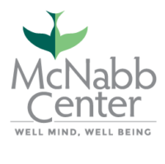
The McNabb Center (Outpatient)
Address: 601 Cumberland St. Chattanooga, TN 37404
Phone Number: 423-266-6751 or 1-800-255-9711
House: Monday – Friday 8am – 5pm

Services Provided: Outpatient mental health services, Counseling/therapy, Alcohol and drug intensive outpatient services, Case management. Homeless Services.
Eligibility: TennCare, Commercial insurance, Cover kids
Payment Information: Varies depending on coverage plan.

Homeless Health Care Center VIP Program (*financial assistance)
Address: 730 E 11th St. Chattanooga, TN 37403
Phone Number: 423-265-5708
Website: www.freeclinics.com
Hours: Monday - Friday 7:30am – 4:00pm
Homeless Healthcare center provides intensive outpatient substance abuse treatment as time permits for adults 18-80. Referral to drug/alcohol free shelter.

Volunteer Behavioral Health - Johnson Mental Health Center (IOP)

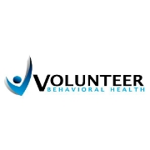
(*financial assistance available)
Address: 420 Bell Ave Chattanooga, TN 37405
Phone Number: 423-634-8884
Website: www.vbhcs.org
Hours: Monday - Friday 8:00am – 5:00pm
Outpatient treatment for co-occurring disorders, outpatient counseling, care coordination, medication assessment and medication management

Parkridge Valley Behavioral Health System (Residential and IOP)
Address: 2200 Morris Hill Rd Chattanooga, TN 37421
Phone Number: 423-499-2300
Website: www.parkridgevalley.com

Parkridge Valley offers treatment for addictive disorders, including drug and alcohol addiction. The intensive outpatient program is designed to help adults and seniors achieve long-term abstinence and recovery from addiction while maintaining their normal lifestyles. Treatment consists of education, introducing and reinforcing processes, the inclusion of family and support systems, aftercare groups, and an introduction to 12-step concepts.


Spero Health (Outpatient)
Address: 7030 Lee Highway Suite 201 Chattanooga, TN 37421
Phone Number: 423-301-5930
Website: www.sperohealth.com
Hours: Monday – Friday 9am – 5pm

Spero Health, Inc., is an integrated healthcare services organization specializing in local and affordable outpatient care for individuals suffering from substance use disorder with a mission to “Save Lives, Instill Hope, and Restore Relationships.”

CHILD CARE

Head Start and Early Head Start
Head Start programs prepare America’s most vulnerable young children to succeed in school and in life beyond school. To achieve this, Head Start programs deliver services to children and families in core areas of early learning, health, and family well-being while engaging parents as partners every step of the way.

Avondale Head Start / Early Head Start
Address: 2302 Ocoee St. Chattanooga, TN 37406
Phone Number: 423-643-6503 or 423-643-6533
Hours: 8:15am – 2pm

Cedar Hill Head Start / Early Head Start
Address: 4701 Divine Ave. Chattanooga, TN 37407
Phone Number: 423-643-6648 or 423-643-6640
Hours: 8:30am – 1pm

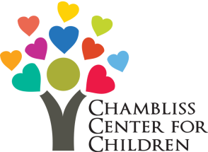
Chambliss Center for Children
Address: 315 Gillespie Rd Chattanooga, TN 37411
Phone Number: 423-698-2456
Website: https://www.chamblisscenter.org/
Hours: Monday - Thursday 6:30am – 12am
Friday 6:30am – 1am
Saturday 6:30am – 12am
Sunday 6:30am – 10pm

Our Extended Child Care (ECE) program offers high-quality early childhood education and child care to children from 6 weeks old - 12 years old on a sliding fee scale. The program operates 24 hours per day, 7 days per week and serves parents who are either working or in school. The goal is to provide the best possible education to young children, in preparation for Kindergarten, and to provide a safe place for our older children before and after school.

Children’s Academy of Early Learning/Education
Address: 1800 S Greenwood Ave. Chattanooga, TN 37404
Phone Number: 423-493-0771
Hours: Monday – Friday 6:30am – 5:30pm

Daisy Head Start / Early Head Start
Address: 9531 Ridge Trail Rd. Soddy Daisy, TN 37379
Phone Number: 423-643-6460
Hours: 8:15am – 2pm

Maurice Kirby Child Care Center Head Start / Early Head Start
Address: 2500 S. Market St. Chattanooga, TN 37408
Phone Number: 423-266-1802
Hours: Monday – Friday 6:30am – 5:30pm

The center cares for 13 or more children with a maximum capacity of 99 children. The child care center helps with children in the age range of 6 weeks to 5 years. The provider also participates in subsidized child care program. Sibling discount available. Wheelchair accessible, scholarship available, sliding scale available.

Pro Re Bona Child Care Head Start / Early Head Start
Address: 1707 Dodds Ave. Chattanooga, TN 37404
Phone Number: 423-622-2632
Hours: 8:30am – 1pm

Youth and Family Development Center Head Start / Early Head Start
Address: 501 W 12th St. Chattanooga, TN 37402
Phone Number: 423-643-6400
Website: www.chattanooga.gov/youthandfamily
Hours: Monday - Friday 8:00am – 4:30pm


Little Miss Mag Early Learning Center
Address: 225 Lookout St. Chattanooga, TN 37403
Phone Number: 423-266-5286
Website: http://www.littlemissmag.org/
Hours: Monday - Friday 6:30am – 5:30pm

Newton Child Development Center
Address: 1301 Grove St. Chattanooga, TN 37404
Phone Number: 423-266-4341
Hours: Monday – Friday 7am – 5pm
Newton Child Development Center provides the critical ministry of high quality child care services in Chattanooga's Westside Community.


Urban League of Greater Chattanooga, INC. - LEAPs After School Program
Address: 730 E M.L. King Blvd. Chattanooga, TN 37404
Phone Number: 423-756-1762
Website: www.ulchatt.net
Email: info@ulchatta.net
Hours: Monday - Friday 8:30am – 5pm
LEAPs is an after-school academic enrichment program focused on reducing the achievement gaps in all areas of S.T.E.A.M. (Science, Technology, Engineering, Arts and Math) for minority and low-income students attending one of the five inner-city elementary schools in Hamilton County. Our target opportunity zone schools include Barger Academy of Fine Arts, Calvin Donaldson Environmental Science Academy, East Lake Elementary, Orchard Knob Elementary, and Woodmore Elementary. Each school serves a high minority population (75% African American and 18% Hispanic) and faces severe poverty; 96% of students are low income and receive free or reduced lunch. Sadly, an African-American or low-income student in our target schools is three times more likely to score below proficient in reading and math than a Caucasian peer on the T-CAP (Tennessee Comprehensive Assessment Program). This program was established to improve state standardized test scores and introduce students to a variety of careers in S.T.E.A.M.
​
Volunteer Community School

Address: 506 Spears Ave. Chattanooga, TN 37405
Phone Number: 423-267-5800

The center cares for 13 or more children with a capacity of 80 children. The child care center helps with children in the age range of 6 weeks to 5 years. The provider also participates in subsidized child care program. Sibling discount available. Wheelchair accessible, sliding scale available.

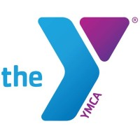
YMCA Downtown
Address: 301 W 6th St. Chattanooga, TN 37402
Phone Number: 423-266-3766
Hours: Monday - Friday 5am – 9pm
Saturday 6am – 6pm
Sunday 1pm – 5pm

CHILD SUPPORT

Maximus Child Support Services of Hamilton County
Address: 5751 Uptain Rd. Suite 106 Chattanooga, TN 37411
Phone Number: 423-508-6500
Website: https://maximus.com/child-support
Hours: Monday – Friday 7:30am – 5pm

The Tennessee Child Support Parent Employment Demonstration (CSPED)

Address: 5751 Uptain Rd. Suite 206 Chattanooga, TN 37411
Phone Number: 423-508-6530
Hours: Monday - Friday 8am – 4:30pm
Email: chrissie.holland@tn.gov

CSPED is a Child Support program designed to help Noncustodial Parents (NCPs) find employment so they can pay their court order. They are located in 3 cities across the state (Memphis, Nashville and Chattanooga). They work closely with the Department of Labor and other partnering agencies to provide NCPs the help they need to overcome barriers in life. Services may include: help finding a job, job training, parenting classes, and/or referrals to other needed services.
CLOTHING ASSISTANCE

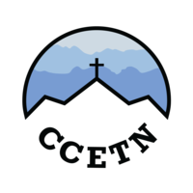
Catholic Charities Pregnancy Help Center
Address: 5720 Uptain Rd. Suite 4800, Chattanooga, TN 37411
Phone Number: 423-826-0673
Email: phc@ccetn.org
Hours: Monday – Friday 10am – 4pm
The churches and other organizations that are part of the network will only have maternity or baby clothing in Hamilton County. There may also be free diapers, pregnancy testing kits, and other goods. Referrals are given to crib or car seat programs, including agencies that install car seats for free for safety reasons.

The Pregnancy Help Center offers Earn While You Learn educational credits redeemable for infant or even toddler items. Credits can be used for daily needed infant supplies, as well as larger ticket items, such as car seats, cribs, etc.

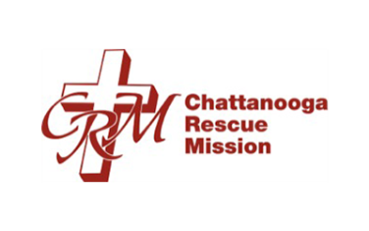
Chattanooga Rescue Mission
Address: 1512 S. Holtzclaw Ave. Chattanooga, Tennessee 37404
Phone Number: 423-756-3126
Website: www.chattanoogarescuemission.com
Hours: Monday – Friday 9am – 4pm

Shelter guests can receive clothing. There may also be blankets, meals, hygiene items such as soap, and other material goods.

Chattanooga Community Clothing Department and Kitchen
Address: 727 E 11th Street Chattanooga, TN 37403
Phone Number: 423-756-4222
Website: www.homelesschattanooga.org
Hours: Tuesday – Saturday 10am – 2pm

Clothing and basic goods are provided at no charge to those in need through the Consider the Lilies Clothing Program. Whether you are in need and receiving give-away or are a paying customer, you will shop from the same racks and check out at the same register.

Consider the Lilies is located at the corner of East 11th and Peeples Street, across the street from the Homeless Health Care Center.

See a case manager for needs beyond a basic change of clothing and seasonal attire.

The Samaritan Center - Thrift Shop
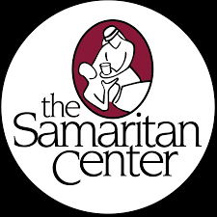
Address: 9231 Lee Highway Ooltewah, Tennessee 37363
Phone Number: 423-238-7777
Website: thesamaritancenter.net
Hours: Sunday 1pm – 5pm, Monday – Thursday 9am – 6pm

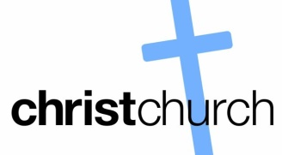
The non-profit location is open a few days per week. There will be low cost household items, kitchen appliances, furniture, clothes, and school items. Students in Hamilton County may be given shoes, books, bags, and other free back to school supplies. Some families recovering from a disaster are given a voucher to shop with.
Christ United Methodist Church

Address: 8645 E. Brainerd Rd. Chattanooga, TN 37421
Phone Number: 423-892-9363
Hours: Sunday 8:30am – 7pm, Monday – Friday 8:30am – 4:30pm

They pass out basic clothes such as shoes, shirts, blankets, and more. Some small household goods, such as a table or other furniture item may be offered in Hamilton County too.


Forgotten Child Fund
Address: 1715 East Main St. Chattanooga, TN 37404
Phone Number: (423) 697-0031
Website: www.forgottenchildfund.org
Hours: Monday – Friday 10am – 2pm
During the winter there will be coats for children from low income families, boots, gloves, and other clothes for the youth in Hamilton County.


Ladies of Charity
Address: 2821 Rossville Blvd. Chattanooga, Tennessee 37404
Phone Number: (423) 698-2846
Hours: Tuesday, Wednesday, Friday 10am – 2pm
Vouchers are given for items ranging from clothes to work attire or food. Seniors in Hamilton County can seek assistance, including transportation, from the charity more often than others.


First Baptist Church of Soddy Daisy
Address: 10185 Dayton Pk Soddy Daisy, Tennessee 37379
Phone Number: 423-332-2814

GED classes for children, clothes, hygiene items, and more are at the non-profit. There may be some school items for teenagers or kids, books, sneakers and more.


Northside Neighborhood House
Address: 211 Minor Street Chattanooga, TN 37405
Phone Number: 267-2217
Website: www.nnhouse.org
Hours: Monday – Saturday 10am – 6pm

One focus is on students. GED classes, notebooks for class, uniforms, and other aid is passed out by volunteers. School uniforms, book bags, backpacks, and more is offered too.

DOMESTIC VIOLENCE SERVICES


The Crisis Resource Center (Partnership for Families, Children & Adults)
Address: 1800 McCallie Avenue Chattanooga, TN 37404
Phone Number: 423-755-2822
Website: www.partnershipfca.com
Email: info@partnershipfca.com
Crisis Hotline: 423-755-2700 – Available 24/7, completely confidential
The Partnership’s Family Violence Center provides immediate shelter to individuals and their children who are victims of domestic violence. The location of the shelter is confidential. A case manager will assess the individual's current needs and create goals that may include counseling, legal advocacy, housing and employment. Counseling referrals are available to anyone who has experienced domestic violence and does not require the individual to be a resident of the shelter. A Domestic Violence Support Group for non-residents is held every Thursday from 6:30pm until 7:30pm.

The McNabb Center
Address: 601 Cumberland St. Chattanooga, TN 37404
Phone Number: 423-266-6751
Hours: Monday – Friday 8am – 5pm

Our caring staff works with women, men and their children who have experienced domestic violence. Staff can assist victims in finding the support and resources to live a life free from abuse. In addition to outreach and counseling services, the Center offers a safe emergency shelter and transitional housing for individuals in need.
The Domestic Violence Crisis Hotline is answered 24 hours a day: (865) 637-8000.
The McNabb Center offers a full continuum of mental health care, addiction treatment, social services and victim services. We care for children, adolescents, families and adults. To learn more about the Center or to access the care you need, call us at 1-800-255-9711.

To schedule an appointment or initial assessment, call us at 1-800-255-9711. Our caring staff will connect you with the appropriate service for your needs. The Center accepts TennCare as well as numerous commercial insurance options.
EDUCATION & TRAINING


AIM Center
Address: 472 W M.L. King Blvd. Chattanooga, TN 37402
Phone Number: 423-624-4800
Website: www.aimcenterinc.org
Hours: Monday - Friday 8am – 4pm

The AIM Center provides skill building opportunities for members who have an interest in improving their workplace skills. Members can participate in or lead structured activities designed to improve workplace relationships, basics of office management, and guest relations.

Partnership for Families, Children & Adults - Building Stable Lives Program
Address: 1800 McCallie Avenue Chattanooga, TN 37404
Phone Number: 423-755-2822
Website: https://www.partnershipfca.com/121/building-stable-lives

Office Locations:
- Alton Park Office - 423.265.3114
- East Chattanooga Office - Class Schedule - 423.698.1526
- East Lake Office - 423.702.0218

The Building Stable Lives program is free to all participants. Clients are referred from the United Way’s 211 Call Center. The Life Coach will call each referral to schedule an intake assessment, which is completed at the Building Stable Lives site. Life Coaches provide resume writing & interview skills training, job search assistance, financial education, and referrals to several local agencies for services we are unable to provide on-site. Each time a Life Coach meets with a client, the goal is to use client-focused questions to facilitate improvement in decision-making & problem-solving skills. In addition to program services for clients, community members are able to participate in classes provided by Life Coaches as well as access computer labs for job searching at each neighborhood site.

Chattanooga College

Main Campus: 5600 Brainerd Rd. Suite B38 Chattanooga, TN 37411
Phone: 423-305-7781
Satellite Campus: 248 Northgate Mall Dr. Chattanooga, TN 37415
Phone: 423-624-0078
Website: https://www.chattanoogacollege.edu/


Chattanooga State Community College

Address: 4501 Amnicola Hwy. Chattanooga, TN 37406
Phone: 423-697-4400
Website: www.chattstate.edu

TCAT at Chattanooga State is a leading provider of hands-on, high-demand, skills training programs designed to prepare you for the job market. Most TCAT students are able to start their career within just one year.

EOC (Educational Opportunity Center)

Address: 615 McCallie Ave. Room 403 Chattanooga, TN 37403
Phone Number: 423-425-1702
Hours: Monday - Friday 8:30am – 5pm

The Educational Opportunity Center offers free counseling and information to those who do not already have a four-year degree and who want to enter or continue a program of post-secondary education. Services provided include: Finding a GED program, choosing a college, academic advice, career counseling, completing college applications, filling out the FAFSA, learning about Tennessee HOPE Scholarships as well as additional scholarships and grants, financial education and counseling, testing and tutoring.

Goodwill Industries

Address: 3500 Dodds Ave. Chattanooga, TN 37407
Phone Number: 423-629-2501
Toll Free: 866-272-2061
Website: www.goodwillchatt.org
Hours: Monday – Friday 8:30am – 4:30am

Goodwill employment programs provide vocational, work experience, job placement, readiness training and workforce re-entry support. We assist individuals in finding work despite any barriers that might prevent them from finding meaningful employment, such as lack of experience, lack of education, disabilities and not knowing what is expected in the workplace.

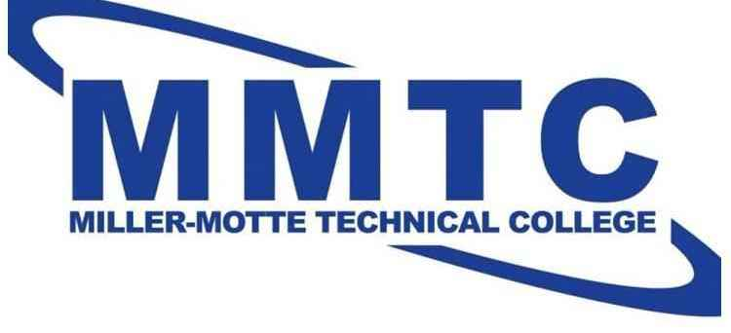
Miller-Motte Technical College

Address: 6397 Lee Highway, Suite 100 Chattanooga, TN 37421
Phone Number: 423-414-3247
Website: https://www.miller-motte.edu/campuses/chattanooga-career-training

Miller-Motte College has 11 convenient locations and offers Beauty & Wellness, Business, Healthcare, Protective Services, Skilled Trades-CDL and Technology courses and programs. They also offer 100% online programs through their Wilmington location (Business Administration, Criminal Justice, IT Support Specialist and Medical Billing and Coding). All graduates have access to Career Assistance which includes guidance from our Career Services team, resume updates, workshops and more. Financial aid is available for those who qualify.


The University of Tennessee at Chattanooga – Center for Professional Education

Address: 615 McCallie Ave. Chattanooga, TN 37403
Phone Number: 423-425-4111
Website: www.utc.edu

The Center for Professional Education is dedicated to seeing you advance – whether that be your career, your life or your knowledge. Our goal is to provide learning opportunities that are engaging and inspiring. After attending a course, we want you to walk away feeling empowered and ready to achieve your own goals and desires.

Our programs are offered both online and on-campus because they are focused on the local workforce. Our goal is to help individuals acquire the skills or credentials needed to be successful in today’s rapidly changing economy. We value our commitment to providing quality training programs that are relevant and valuable to workers in a variety of industry sectors.

The American Job Center

Address: 5600 Brainerd Rd (East Gate Town Center) Chattanooga, TN 37411

Phone Number: 423-894-5354
Website: www.secareercenter.org
Hours: Monday - Friday 8am – 4:30pm

Career and training services for Adults, Dislocated Workers and Youth, Adult Education and Literacy Act programs that lead to attainment of a high school equivalency diploma, basic skills upgrades, or English language acquisition, job search assistance, job referral and placement, services for employers, programs providing employment and training for individuals with disability, and many more.

Tennessee Department of Labor and Workforce Development

Phone Number: 1-844-688-7944

Website: https://www.tn.gov/workforce.html

The division of Workforce Services focuses on job placement and training programs for Tennesseans.

Urban League of Greater Chattanooga, INC.

Address: 730 E M.L. King Blvd. Chattanooga, TN 37404

Phone Number: 423-756-1762
Website: www.ulchatt.net
Email: info@ulchatta.net
Hours: Monday - Friday 8:30am – 5pm

The Urban League’s Workforce Development program assists unemployed or underemployed individuals within Chattanooga. The Urban League Workforce Program aligns its services with the WOIA (Workforce Innovation and Opportunity Act) in order to ensure that individuals are well equipped with the skills needed to obtain employment. These job training services will include computer training, job searching, resume building, and interview preparation. The program also provides annual job fairs, resume building classes, computer coding classes, and employer informational sessions.
​
The program objectives are designed to assist individual’s opportunities for employment, education, and further training and services to be competitive in the labor market and suitable to the demands of employers in the global economy.

Vocational Rehabilitation Hamilton County Regional Office

Address: 311 E M.L. King Blvd. Chattanooga, TN 37403
Phone Number: 423-634-6700

The Vocational Rehabilitation Program (VR) provides a variety of individualized services to persons with disabilities in preparation for their employment in the competitive labor market. VR advocates employment outcomes for clients that are consistent with their individual strengths, resources, abilities, capabilities and informed choice.

HOMELESS SHELTERS

Chattanooga Rescue Mission
Address: 1512 S. Holtzclaw Ave. Chattanooga, TN 37404
Phone Number: 423-756-3126
Website: www.chattanoogarescuemission.com

The shelter can house 46 men and 23 women. The Chattanooga Rescue Mission has the only totally free Temporary Emergency Overnight Shelter (TEOS) open year-round in our city serving men, women and young children.

CHATT Foundation (previously Chattanooga community Kitchen) (Day Shelter)

Address: 727 E 11th Street Chattanooga, TN 37403
Phone Number: 423-756-4222
Website: www.homelesschattanooga.org
Hours: Everyday 7am – 5pm

Day Center: services include: restrooms and showers, telephones (to make local calls), mail (to receive correspondence/get identification), computer access, sitting area, washers/dryers, hygiene items, foot care, educational resources and programming (including artistic and musical programs), case management (including outside agency collaboration), meditation space, and much more.

The Kitchen: Three meals are served each and every day to homeless and low-income men, women and youth. If you’re in need of food come visit us today.
“Consider the Lilies” Store: Welcome! We’re glad you’re here. If you’re in need, we’ve got clothing and basics at no charge at our “Consider the Lilies” store. It’s at the corner of E. 11th and Peeples Street (across the street from the Homeless Health Care Center) . On-site laundry services available.
Hours: Monday through Friday from 10:00am to 3:00pm
Note: Please see a case manager for needs beyond a basic change of clothing or seasonal attire.


Chattanooga Room in the Inn (CRITI)
Address: 230 N Highland Park Ave. Chattanooga, TN 37404
Phone Number: 423-624-6144
Website: www.chattanoogaroomintheinn.com

Chattanooga Room in the Inn (CRITI) is a three to nine month residential program for homeless women and children. Services provided at CRITI are free of charge and include transitional housing, three meals a day, access to affordable or free health care, life skills training, parenting classes, mentoring, assistance with finding affordable housing, and case management services. The 24-hour-a-day program allows the women and their children to find stability, thereby increasing their opportunities and chances for independence once they leave the program.


Family Promise of Greater Chattanooga (Day and Overnight Shelter)

Address: 1184 Baldwin St. Chattanooga, TN 37403
Phone Number: 423-756-3891
Website: www.familypromisechattanooga.com
Email: contactfpgc@gmail.com

The Overnight Shelter Program is our traditional, faith-based program that operates in area congregations and continues to provide food, shelter, and hospitality to families in need. Over fifty area churches and synagogues currently partner together to host and support efforts to provide temporary housing for families, which is truly a cost-effective mobilization of community resources. Seventy-five to eighty percent of families exit this program to stable housing, either employed or with income supports if disabled and securely linked to supportive and follow-up services.

The Day Center Program provides food, transportation, day shelter, shower and laundry facilities, case management, life skills and educational classes, computers to develop resumes and apply online for jobs and housing, indoor and outdoor play areas for children, and a nap room. As the name suggests, our families stay here during the day.
​
The Centralized Intake Program provides intakes, assessments, case management, emergency assistance, and secure linkage to existing community resources for supportive services, guiding families to services, and housing.

Our Going Home Program is a partnership between Family Promise, the Chattanooga Housing Authority, and local builders and property owners. Family Promise screens and selects families for placement in public and renovated and newly constructed housing. We also provide one year of case management services where property owners can access assistance and guidance from a case manager for any family issues.
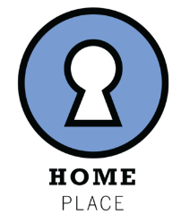
Home Place
Address: 5720 Uptain Rd. Chattanooga, TN 37411
Phone Number: 423-698-9079
Website: ccetn.org/home-place

A residential facility that provides a stable, healthy environment and intensive case management services for individuals who are homeless with limited income who are living with HIV/AIDS. Offers fully furnished efficiency style apartments, with private baths that feature all the necessary items for comfortable living.

Partnership for Families, Children, and Adults
Address: Location private for victims
Phone Number: 423-755-2700

The Family Violence Center provides immediate shelter to individuals and their children who are victims of domestic violence. The location of the shelter is confidential. The shelter’s living quarters consist of dormitory style rooms with a communal kitchen, bathroom and living room.


Salvation Army (Day Center)
Address: 800 McCallie Ave. Chattanooga, TN 37403
Phone Number: 423-756-1023
Website: www.salvationarmyusa.org/usn/

Before temperatures dip below freezing, The Salvation Army opens its doors for overnight emergency shelter to those that don’t have a place to stay. It is also open for inclement weather when it is over 90 degrees out.

The ReCreate Café, The Salvation Army Day Center, located at 800 McCallie Avenue, is always ready to serve. We provide toiletry items, coats, gloves, coffee, snack, and new space heaters for low-income residents.


Union Gospel Mission (Men’s, faith-based, residential program)
Address: 124 Signal Hills Dr. Chattanooga, TN 37405
Phone Number: 423-752-4998
Website: www.theuniongospelmission.org
Email: mail@theuniongospelmission.org

The G.R.A.C.E. Discipleship Program is designed to be a six month, residential, program for men seeking to address “life-controlling” issues in their lives. The majority of clients in this program come from a background of drug addiction and/or alcoholism. This program will also help address other issues of addiction and/or a life of poor decision making.
A curriculum that combines group classes, self-study, daily structure, and strong personal accountability; provides the necessary tools for our clients to achieve the change in their lives that they seek.

Once our clients have completed the G.R.A.C.E. Discipleship Program, we have found that the majority of them are in need of a “next step”. For those who don’t have a support system in place, we provide them with housing, help with job search, budgeting, and re-integrating into “normal” society.
Our After-Care program provides that “extra step” in helping our clients transition into a productive life.
EMPLOYMENT
Chattanooga State Adult Education Department
Address: 1501 Riverside Dr. Suite 260 Chattanooga, TN 37406
Phone Number: 423-855-4443

Chattanooga State conducts day and evening Adult Education/GED classes on the main campus and throughout the community for anyone 17 or older. All classes have individualized instruction.
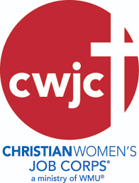
Christian Women’s Job Corps of Chattanooga

Address: 401 Gateway Ave. Chattanooga, TN 37402

Phone Number: 423-535-0291 or 706-224-2908

Email: chattcwjc@gmail.com

Website: cwjc-chattanooga.com

We seek to empower women to become confident, motivated individuals, prepared for self-sufficient lifestyle, impacted by the love of God, and equipped to give back to the community. Each term of twelve weeks includes training segments pertaining to employment such as how to locate potential jobs, resume writing, interview skills, workplace behavior, and appropriate dress. Women are also taught life skills such as wise decision making, setting SMART goals, and creating a mental and spiritual state of hope and healing. They will be introduced to Biblical women role models and God’s promise for their lives. Participants are paired with women mentors for encouragement accountability, and assistance in setting and reaching their goals


Goodwill Industries
Address: 3500 Dodds Ave. Chattanooga, TN 37407
Phone Number: 423-629-2501
Website: www.goodwillchatt.org

Goodwill employment programs provide vocational, work experience, job placement, readiness training and workforce re-entry support. We assist individuals in finding work despite any barriers that might prevent them from finding meaningful employment, such as lack of experience, lack of education, disabilities and not knowing what is expected in the workplace.

Hope for the Inner City
Address: 1800 Roanoke Ave. Chattanooga, TN 37404
Phone Number: 423-698-3178
Website: www.hopefortheinnercity.com
Hours: Monday – Friday 8am – 5pm

The workforce development department engages, invests in and empowers our neighbors with essential jobs skills training and employment opportunities. Invest Hope is a six-month workforce development training geared towards at risk adults. This initiative provides a paid stipend for soft and hard skill training, as well as assistance with removing barriers to employment. At the end of the program, participants are assisted with gaining immediate access to permanent employment. Job placement services provide short-term soft skills training, job referral, and job placement services to our neighbors, in collaboration with local employers and staffing firms.

Metro Industrial

Address: 5791 Brainerd Rd. Chattanooga, TN 37407


Phone Number: 423-225-9675

Website: http://www.metroindustrialjobs.com/

Hours: Monday – Friday 8am – 5pm

Metro Services specializes in manufacturing, warehousing and retail. We offer temporary work that is often a bridge to full time employment with our client companies. We also have full time positions available directly with our clients.

Many of our temporary assignments lead to full time positions, which is a testimony to our ability to accurately match people to jobs and the needs of our client companies.
In our desire to help others, we treat applicants as people, preparing them for employment with our attention, patience, respect and integrity. A few benefits include:
- Skills Training and Development
- Weekly pay
- Direct Deposit or Paycards
- Medical And Dental Insurance

Project Return

Address: 620 Lindsay St. Suite 100 Chattanooga, TN 37403

Phone Number: 423-609-8986

Website: http://www.projectreturninc.org

Hours: Monday – Friday 8am – 4:30pm

Project Return works with people who want more than anything to start a new life after incarceration and leave prison behind. We are committed to every person’s humanity and dignity, and their right to live fully and freely in this world.

Individualized job search strategy: résumé creation, job leads, mock interviews, computer training, networking events, job search planning, and job coaching.

Skills Development: To match the growing industries in our region, we provide our people with the education necessary to take advantage of employment opportunities.

Workforce Development: Employment is the most important factor for successful reentry. We deliver a 3-day curriculum – every week, to a new group of just-released individuals – that emphasizes soft skills and gets people job-ready.

Employment Opportunities: Our Business Development team builds relationships with employers across the city and region, and engages to meet their workforce needs.
Employment means everything after incarceration, and we are peoples’ best first job after prison.
Launched in 2013, Project Return Opportunities for Employment (PROe) bridges the chasm between incarceration and regular employment. PROe functions as a temporary staffing service, in which Project Return meets the workforce needs of our employment partners, while our transitional employees earn, learn, and succeed.
Eligibility: A person convicted of a felony in the last 12 months. A person who was serving time on a felony conviction and released from a correctional facility within the past 12 months. A person who was convicted of a misdemeanor and has served a minimum of 3 consecutive months in jail and released in the past 12 months.
The American Job Center
Address: 5600 Brainerd Rd Suite A5 Chattanooga, TN 37411

Phone Number: 423-894-5354
Website: https://www.secareercenter.org/www
Hours: Monday - Friday 8:00am – 4:30pm
Career and training services for Adults, Dislocated Workers and Youth, Adult Education and Literacy Act programs that lead to attainment of a high school equivalency diploma, basic skills upgrades, or English language acquisition, job search assistance, job referral and placement, services for employers, programs providing employment and training for individuals with disability, and many more.

FINANCIAL ASSISTANCE & MONEY MANAGEMENT


American Red Cross
Address: 4115 S Access Rd. Chattanooga, TN 37406
Phone Number: 423-265-3455
Website: www.redcross.org
Hours: Monday - Friday 9am – 5pm


The American Red Cross provides services throughout the community; however, most of their services are not open to anyone based just on need or income, but on very specific needs. We provide emergency food, shelter, clothing, medicine and or eyeglass replacement funds for individuals whose home has been destroyed by a natural disaster, such as a fire or tornado, but not for others. In other words, you do not qualify for services based only on need and/or income, but there must be a qualifying "event",i.e. a house fire or other natural disaster that led to your current situation, in order to qualify, also provide services to armed forces to families in crisis.
Catholic Charities of East, TN
Address: 5720 Uptain Rd. Suite 4200 Chattanooga, TN 37411
Phone Number: 423-267-1297
Website: www.ccetn.org
Catholic Charities of East Tennessee provides services to anyone with demonstrated need, regardless of race, income or religion. They estimate that fewer than 5% of all clients served are catholic.

Chattanooga Department of Youth and Family Development
Address: 501 W 12th St. Chattanooga, TN 37402
Phone Number: 423-643-6400
Website: www.chattanooga.gov/youthandfamily
Hours: Monday - Friday 8am – 4:30pm

Formerly known as Chattanooga Human Services, the mission of the Office of Family Empowerment is to change the lives of low- to-moderate income individuals and families in Hamilton County by collaborating with internal and external partners to provide the services and connections necessary to achieve self-sufficiency.

They offer some emergency assistance (with rent, mortgage, or water) for those experiencing a crisis by appointment only.

Choices Pregnancy Resource Center (East Chattanooga Location)
Address: 6232 Vance Rd, Chattanooga, TN 37421

Phone Number: 423-892-0803
Website: www.choiceschattanooga.org
Hours: Monday, Tuesday, Friday 9am – 4pm
Wednesday 10am – 4pm
Thursday 9am – 7pm

Their first-time parenting program is individualized for women and men and consists of one-on-one support with your client educator each week. The program is for the duration of the pregnancy and can continue for the first year of your child’s life. Participants earn credits to shop in our boutique for items such as diapers, wipes, clothing, car seats, and more.
They provide baby items such as clothing, diapers and more to women and men who participate in their parenting programs.

Families First
Address: 1817 Dodds Ave. Chattanooga, TN 37404
Phone Number: 423-698-1190
Website: www.tn.gov

Provides assistance to families who have children, and are experiencing financial difficulties. These benefits are time-limited to 60 months in a participant’s lifetime.

Hope for the Inner City
Address: 1800 Roanoke Ave. Chattanooga, TN 37404
Phone Number: 423-698-3178
Website: www.hopefortheinnercity.com
Hours: Monday – Friday 8am – 5pm

Provides a variety of services for low income individuals and families through partnership with local churches and other concerned parties. Operates financial assistance for emergency needs such as food, clothing, medications, rent, and holiday assistance. Offers dental services and gives legal referrals. Offers counseling for self-help.

The Low Income Home Energy Assistance Program (LIHEAP)

Phone Number: 423-643-6434
Website: https://epb.com/liheap

LIHEAP helps keep families safe and healthy through initiatives that assist families with energy costs such as utility bills. They provide federally funded assistance in managing costs associated with: home energy bills, energy crisis, and weatherization and energy related minor home repair.
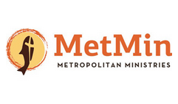
Metropolitan Ministries
Address: 4001 Rossville Blvd. Chattanooga, TN 37407
Phone Number: 423-624-9650, 423-624-9654
Website: www.met-min.org
Hours: Monday – Thursday 9am for first 20 callers

MetMin staff and volunteers help clients each Monday through Wednesday. Wednesday is reserved for seniors over the age of 62. There are 35 assistance slots available each of those days. The demand for our help is quite high, though, and those 35 slots are often filled by the time we open our doors at 8:00 am.

Clients are interviewed on a first-come, first-served basis rather than by appointment. There are no geographic limits.
Standard assistance areas include:
- Past due utility bills (electricity, gas, water, and sewer)
- Past due rent payments
- Food vouchers to the Chattanooga Area Food Bank (available only on Mondays and Tuesdays), and
- Our On-site Grocery Store for Seniors (available only on Wednesdays).

From the 1st to the 15th of each month MetMin helps with rent, water, sewer, gas, and food. From the 15th to the end of each month, we assist with EPB (electricity only), water, sewer, gas, and food.

MetMin helps with one resource at a time. All clients are encouraged to meet with our Resource Manager in order to access other beneficial goods and services.

Northside Neighborhood House (North Chattanooga Location)
Address: 211 Minor St. Chattanooga, TN 37405
Phone Number: 423-267-2217
Website: www.nnhouse.org
Hours: Monday – Friday 8:30am – 4:30pm
Free items are provided for free to clients of certain collaborating agencies: American Red Cross, CADAS, Metropolitan Ministries, Room in the Inn. Northside Neighborhood House also provides help with emergency needs for utilities, food, and prescription medications.

Northside Neighborhood House (Red Bank Location)
Address: 3605 Dayton Blvd. Red bank, TN 37415
Phone Number: 423-386-5811
Website: www.nnhouse.org
Hours: Monday – Saturday 10am – 6pm

Free items are provided for free to clients of certain collaborating agencies: American Red Cross, CADAS, Metropolitan Ministries, Room in the Inn. Northside Neighborhood House also provides help with emergency needs for utilities, food, and prescription medications.

Partnership for Families, Children, Adults Consumer Credit Counseling
Address: 1800 McCallie Ave. Chattanooga, TN 37404
Phone Number: 423-490-5620
Website: www.partnershipfca.com

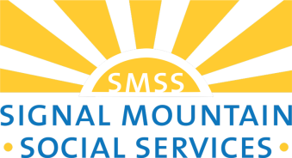
Signal Mountain Social Services
Address: 633 Mississippi Ave. Signal Mountain, TN 37377
Phone Number: 423-886-5982
Website: http://signalmountainsocialservices.org/
Hours:

Signal Mountain Social Services provides tutoring to elementary through high school students, school supplies, Life Skills counseling, a food pantry, compassionate, supportive services for seniors, and when appropriate they can help pay rent and utility bills, help with the cost of prescription drugs and in some cases help with home repairs.


Sleep in Heavenly Peace (Beds for Children)
Phone Number: 844-432-2337 / 844-432-BEDS
Website: https://www.shpbeds.org/

We're a group of volunteers dedicated to building, assembling and delivering top-notch bunk beds to children and families in need. At SHP, we fully believe that a bed is a basic need for the proper physical, emotional, and mental support that a child needs.

The Samaritan Center
Address: 9231 Lee Highway Ooltewah, TN 37363
Phone Number: 423-238-7777
Hours: Monday – Thursday 9am – 8pm Sunday 1pm – 5pm
Website: https://thesamaritancenter.net/

The Samaritan Center provides help with: Utilities, rent, or life-sustaining medications. Food through their Community Food Pantry. Their services can be accessed by calling the United Way at 211. Clothing, furniture and household items through their thrift store. School supplies. Cleaning supplies and personal care products that cannot be purchased with food stamps.

United Way
Address: 630 Market St. Chattanooga, TN 37402
Phone Number: 423-752-0300
Website: https://unitedwaycha.org/
Hours: Monday – Friday 8:30am – 5pm

Contact United Way’s 2-1-1 for information about community resources and assistance. Speak with a Community Resource Specialist by dialing 2-1-1, 423-265-8000, or toll-free at 1-866-921-3035.

2-1-1 offers information about food, housing, employment, transportation, health services, eldercare, and other crisis hotlines.

FOOD ASSISTANCE


Bridge Refugee & Sponsorship
Address: 4791 Hal Dr. Suite A Chattanooga, TN 37416
Phone Number: 423-954-1911
Website: www.bridgerefugees.org
Email: volunteermanager@bridgerefugees.org
Hours: 9am – 5pm

Bridge empowers refugees to become self-sufficient, and we work closely with many people in East Tennessee—including volunteers, employers, and faith-based organizations that sponsor refugees—who are willing to help their new neighbors.


Chattanooga Area Food Bank (Food Boxes and USDA Commodities)

Address: 2009 Curtain Pole Rd. Chattanooga, TN 37406
Phone Number: 423-622-1800
Hours: Monday – Thursday 8am – 4pm and Friday 8am – 2pm

If you live in Hamilton County, dial 211 or text your zip code to 898-211 to request a voucher for an emergency food box. Most of our food is distributed by partner agencies located in 20-counties across Southeast Tennessee and Northwest Georgia.

Chattanooga Baptist Ministry Center
Address: 4500 Elmo Ave. Chattanooga, TN 37409
Phone Number: 423-821-2976


Community Kitchen (Three Meals a Day)

Address: 727 E 11th St. Chattanooga, TN 37403
Phone Number: 423-756-4222
Website: https://www.homelesschattanooga.org/
Hours: Everyday 7am – 5pm

We serve three meals a day every day of the year - no questions asked. We hope the meal will serve as a starting point, helping build a foundation from which we can help you on your path to self-sufficiency. Meals are often cafeteria style, but we're working daily to improve the experience through a program we call "dining with dignity." Through this program, we serve "restaurant style" meals complete with table service and a menu.
Meals times (seven days a week):
• Breakfast 7:00AM to 8:00AM
• Lunch 11:30AM to 12:30PM
• Dinner 3:30PM to 4:30PM

Food not Bombs
Address: 850 Market St. Chattanoga, TN 37402 (Miller Plaza)
Phone Number: 423-507-3842; 423-842-7960
Email: seaturtle531960@gmail.com
Website: http://foodnotbombs.net/
Hours: Sunday at 12:00 p.m.

Food Not Bombs is an all-volunteer movement that recovers food that would otherwise be discarded, and shares free vegan and vegetarian meals with the hungry in over 1,000 cities in 65 countries in protest to war, poverty, and destruction of the environment. We are not a charity but dedicated to taking nonviolent direct action. Our movement has no headquarters or positions of leadership and we use the process of consensus to make decisions. We also provide food and supplies to the survivors of natural disasters, and people participating in occupations, strikes, marches and other protests.

Salvation Army
Address: 800 McCallie Ave. Chattanooga, TN
Phone Number: 423-756-1023
Website: https://www.csarmy.org/

Our Emergency Assistance Program provides critical, short term assistance to low income families and individuals living in our service area, and aids in preventing homelessness by bridging the gap between income and expenses for this underserved demographic in our community.

SNAP (Food Stamps)

Address: 5600 Brainerd Rd. Suite 602-A Chattanooga, TN 37411
Phone Number: 423-634-6200
Website: www.tn.govfns.usda.gov/snap
Hours: 8am – 4:30pm

The supplemental Nutrition Assistance Program (SNAP, formerly known as food stamps) provides nutritional assistance benefits to children and families, the elderly, the disabled, unemployed and working families. SNAP helps supplement monthly food budgets of families with low-income to buy the food they need to maintain a good health and allow them to direct more of their available income toward essential living expenses.

The Emergency Food Assistance Program (TEFAP)
Address: 420 Hogan Rd. Nashville, TN 37220 (TN Department of Agriculture)
Phone Number: 615-837-5530
Website: www.usda.gov

TEFAP is a Federal program that helps supplement the diets of low-income Americans, including elderly people, by providing them with emergency food and nutrition assistance at no cost.

You may be able to get food assistance from a local TEFAP organization in your area in two ways: 1) getting foods from a place like a food pantry to take home or 2) eating a meal with a group of people at a place like a soup kitchen. Whether or not you are eligible to receive TEFAP foods to take home depends on your household income level.

United Way
Address: 630 Market St. Chattanooga, TN 37402
Phone Number: 423-752-0300
Website: www.unitedwaycha.org
Hours: Monday – Friday 8:30am – 5pm

2-1-1 is a free and confidential service helping people across the Tennessee Valley find the local resources they need when they need them. One call to 2-1-1 connects you to someone who can help you navigate the maze of human services to get you to the help you need. 2-1-1 offers information about food, housing, employment, transportation, health services, eldercare, and other crisis hotlines. Their trained information and referral specialists can help you find resources for all of these needs and more. Simply dial 2-1-1 and stay on the line to speak with an information and referral specialist about your needs.

FOOD PANTRIES
Receive an Emergency Food Box
If you live in Hamilton County, dial 211 or text your zip code to 898-211 to request a voucher for an emergency food box.

Visit a Partner Agency
Most of the food is distributed by partner agencies:

1st Baptist Soddy Daisy (Good Shephard)
10185 Dayton Pike
Soddy Daisy , N 37379
Wednesday: 10AM - 1PM, Friday: 12 PM - 1PM for Milk and Produce only
Phone: 423-648-5922

Apison Food Pantry
11304 First Street
Apison, TN 37402
MWF 12PM - 3PM
Phone: 423-464-8008

Chattanooga Community Kitchen
727 East 11th Street
Chattanooga, TN 37403
Hot Meals Daily: Breakfast: 7AM - 8 AM, Lunch: 10:45AM - 11:45AM, Dinner: 3:30PM - 4:30PM
Phone: 423-756-4222

Covenant Baptist Church - Chattanooga
1512 Old Ringgold Rd
Chattanooga, TN 37404
Sunday & Saturday 11:30AM - 1PM
Phone: 423-635-4342

East Ridge Church Of Christ
951 McBrien Rd
East Ridge, TN 37412
Tuesdays: 8AM - 2PM
Phone: 423-894-7221

East Ridge United Methodist Church
1601 Prater Road
East Ridge, TN 37412
Every 1st and 3rd Wednesday of the Month: 2PM - 5PM
Phone: 423-596-4270

Fellowship Baptist Church
5335 Clemons Rd
Chattanooga, TN 37412
Sunday: 12PM - 1PM, Wednesday 5PM - 6PM
Phone: 423-894-8080

Flat Top Independent Church
13616 Jones Gap Rd
Soddy Daisy, TN 37379
Sunday 12PM - 1PM, Wednesday 5PM - 6PM
Phone: 423-332-0001

Grace Bridge Church of Christ
6224 Airpark Dr
Chattanooga, TN 37421
Wednesday 6PM - 7PM, 3rd week of each month
Phone: 243-645-0015

Hamilton County Baptist/HACOBA
4500 St. Elmo Ave.
Chattanooga, TN 37409
Tuesday & Friday 10PM – 1:30PM
Phone: 423-637-8187

Joyful Sound Church of God
3912 4th AVE
Chattanooga, TN 37407
Tuesdays: 11AM - 12PM, Hot Meals Weds & Sat 12PM
Phone: 423-698-1813

New Life Seven Day Adventist
2099 East Main Street
Chattanooga, TN 37404
Wednesday 6PM - 8PM, Saturday 2PM - 4PM

Phone: 423-313-6529

Pilgrim Congregational United Church Of Christ
400 Glenwood Drive
Chattanooga, TN 37404
Every 4th Saturday of the Month: 9:30AM - 11AM
Phone: 423-698-5682

Red Bank Community Food Pantry
Red Bank United Methodist Church
3800 Dayton Blvd. Red Bank, TN 37415
1st & 3rd Thursday of the month
5PM – 6PM
Phone: 423-877-2881
Website: www.redbankfoodpantry.org

Redemption Point Church
3881 Ooltewah Ringgold Rd
Ooltewah, TN 37363
Phone: 423-894-7926

Redemption to the Nations
1907 Bailey Ave
Chattanooga, TN 37404
Sunday 10AM - 2PM, Mon - Fri 9AM - 5PM
Phone: 423-313-6529

Signal Crest United Methodist
1005 Rideway Ave
Signal Mountain, TN 37377
As Needed
Phone: 423-886-2330

Slavic Christian Church
7463 Pinewood Drive
Ooltewah, TN 37363
Wednesday 4PM - 6PM, Friday 9AM - 10AM, 4th week of the month
Phone: 423-424-9459

Soddy Daisy Food Bank
203 Depot Street
Soddy Daisy , TN 37379
Monday 4PM - 5:30PM; Thursday 9AM - 11AM

Phone: 423-760-3489

St. Elmo United Methodist Church
4626 St. Elmo Ave
Chattanooga, TN 37409
Every 2nd Saturday of the Month: 10AM - 11AM
Phone: 423-605-6111

St. Thaddeus Episcopal
4300 Locksley Lane
Chattanooga, TN 37416
Saturday 2PM - 4PM
Phone: 423-892-2377

St. Timothy's Episcopal Church
630 Mississippi Ave
Signal Mountain, TN 37377
Food Boxes are delivered to clients
Phone: 423-866-2281

Standifer Gap Seven Day Adventist
8310 Standifer Gap Rd
Chattanooga, TN 37421
Tuesday and Thursday 11:30AM - 12:30PM
Phone: 423-892-6013

Thankful Baptist Church
980 N Orchard Knob Ave
Chattanooga, TN 37406
Temporarily closed
Phone: 423-756-2268

The Lord's Harvest
9320 South Lee Hwy
Ooltewah, TN 37363
Wednesday - Thursday deliver to homeward bound clients every 2 weeks

Phone: 423-582-0968

The Samaritan Center
9231 Lee Highway
Ooltewah, TN 37363
3rd week of each month Monday - Thursday 8AM - 5PM

Phone: 423-238-7777

Wauhatchie United Methodist Church
3401 Cummings Hwy
Chattanooga, TN 37419
Every 3rd Wednesday of the Month: 12:30PM - 3PM
Phone: 423-825-5766

HEALTH SERVICES


American Cancer Society
Address: 6221 Shallowford Rd. Suite 102 Chattanooga, TN 37421
Phone Number: 423-855-2778
Hours: Monday - Friday 8:30am – 1pm
Reopens 2pm – 4:30pm
Website: https://www.cancer.org/

At the American Cancer Society, we’re on a mission to free the world from cancer. Until we do, we’ll be funding and conducting research, sharing expert information, supporting patients, and spreading the word about prevention. All so you can live longer — and better.

A Step Ahead Chattanooga

Address: 850 Market St. #228 Chattanooga, TN 37402

Phone Number: 423-265-7837
Website: https://www.astepaheadchattanooga.org/
Hours: Monday – Friday 9am – 5pm

Services Provided: Provide information about and free access to long – term, reversible birth control (IUDs and the implant that goes in the arm).
Populations Served: All women of child bearing age.
Eligibility: Must live or go to school in Southeast Tennessee.
Payment Information: Program pays costs that are not covered by TennCare, or commercial insurance. Program covers all costs for uninsured women.


Bethany Christian Services
Address: 930 McCallie Ave. Chattanooga, TN 37403
Phone Number: 423-622-7360
Website: https://bethany.org/locations/us/tennessee/chattanooga
Hours: Monday - Friday 9am – 5pm
When children are in need of a family, we respond. In the U.S., we protect vulnerable children through essential services, including pregnancy counseling, foster care, emergency care, and adoption. We believe family is the essential human care structure, and we work to provide every child the support, safety, and connection they deserve.

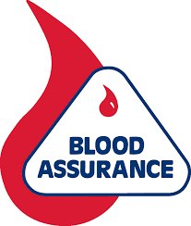
Blood Assurance
Address: 705 E 4th St. Chattanooga, TN 37403
Phone Number: 423-756-0966
Hours: Monday – Friday 8:30am – 6pm
Website: https://www.bloodassurance.org/

Address: 1748 Gunbarrel Rd. Suite 104 Chattanooga, TN 37421
Phone Number: 423-493-7454
Hours: Monday – Friday 8:30am – 6pm
Website: https://www.bloodassurance.org/

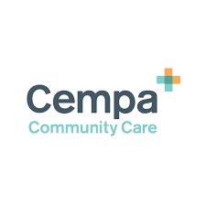
CEMPA Community Care
Address: 1000 E 3rd St. Chattanooga, TN 37403
Phone Number: 423-265-273
Website: www.cempa.org
Email: info@cempa.org
Hours: Monday - Thursday 8am – 5pm; Fri 8am – 1pm

Cempa Community Care is a community health center providing treatment prevention, and support services to those impacted with health disparities with a focus in primary and infectious disease care.

Cempa provides testing, education, and information to break down social stigmas and to help prevent the spread of HIV in 23 counties in Southeast Tennessee disease care.

Chattanooga Hamilton County Health Department (Birchwood Location)
Address: 5625 Highway 60 Birchwood, TN
Phone Number: 423-209-5540
Hours: Monday, Friday 8am – 4pm
Tuesday, Thursday 8am – 3pm
Wednesday 8am – 6pm

Services Provided: WIC (Women, Infant & Children), childhood immunizations, newborn genetic screenings (PKU, Sickle Cell Anemia, Thalassemia, and Hypothyroidism), examination for head lice, pregnancy testing, family planning, emergency contraception, breast and cervical cancer screening program, presumptive TennCare, routine adult immunizations (MMR, Td), primary care for families, HIV testing and counseling.
Population Served: newborns, children, women, men
Payment Information: TennCare, sliding scale fee services offered, Credit/Debit cards

Chattanooga Hamilton County Health Department (Downtown)
Address: 921 E 3rd St. Chattanooga, TN 37403
Phone Number: 423-209-8000
Hours: Monday, Wednesday,
Thursday, Friday 8am – 4pm
Tuesday: 8am – 6pm

Chattanooga Hamilton County Health Department (Ooltewah Location)
Address: 5220 High St. Ooltewah, TN
Phone Number: 423-209-5440
Hours: Monday 8:00am – 6:00pm
Tuesday – Thursday 8am – 4pm
Friday 9am – 4pm

Services Provided: WIC (Women, Infant & Children), childhood immunizations, newborn genetic screenings (PKU, Sickle Cell Anemia, Thalassemia, and Hypothyroidism), examination for head lice, pregnancy testing, family planning, emergency contraception, breast and cervical cancer screening program, presumptive TennCare, routine adult immunizations (MMR, Td), primary care for families, HIV testing and counseling. Dental care for children
Population Served: newborns, children, women, men
Payment Information: TennCare, sliding scale fee services offered, Credit/Debit cards

Chattanooga Hamilton County Health Department (Sequoyah Clinic)
Address: 9527 W. Ridge Trail Soddy Daisy, TN
Phone Number: 423-209-5490
Hours: Monday, Tuesday, Friday 8am – 4pm
Wednesday 8am – 6pm
Thursday 9am – 4pm

Services Provided: Pediatric primary care, WIC (Women, Infant & Children), childhood immunizations, newborn genetic screenings (PKU, Sickle Cell Anemia, Thalassemia, and Hypothyroidism), examination for head lice, pregnancy testing, family planning, emergency contraception, breast and cervical cancer screening program, presumptive TennCare, routine adult immunizations (MMR, Td), children, HIV testing and counseling. Dental care for children
Payment Information: TennCare, sliding scale fee services offered.
Accept as Payment: Cash, Check, Sliding Scale, Medicaid/TennCare, Credit/Debit cards


Cherokee Health Systems
Address: 1032 McCallie Ave. Chattanooga, TN 37403
Phone Number: 423-266-4588
Website: www.cherokeehealth.com

Services Provided: Primary care, Women’s Health, and Behavioral Health services in an integrated health model providing comprehensive, quality care from a team of providers that work together. Acute and chronic illnesses, Hypertension, Diabetes education, treatment, and management. Prenatal care, Sexually transmitted diseases, adolescent care, gynecologic care and surgical interventions. Behavioral health consults on site to address needs as patients are being seen medically combining focused care. Cherokee Health Stytems is recognized nationally for its innovative approach to healthcare. Our staff members are among the leaders in their fields who use the best practices and the latest treatment procedures to help patients.
Populations Served: All women
Eligibility: All women
Payment Information: No payment, Cash, Check, Sliding Scale, Medicaid/ TennCare, Medicare, Commercial Insurance Plans

Children’s Hospital Urgent Care
Address: 910 Blackford St. Chattanooga, TN 37403
Phone Number: 423-778-6011
Website: www.erlanger.org/childrens
Hours: Open 24 hours/day, 7 days/week, 365 days/year

Services Provided:
Medical Services: Ambulatory care, anesthesiology, cardiology, critical care, child life program, developmental behavioral pediatrics, endocrinology, gastroenterology, genetics, hematology/oncology,
infectious diseases, neonatology, nephrology, neurology, oncology, pediatrics, psychology, pulmonology, radiology, respiratory, urology
Emergency Services: LifeForce/neonatal transport, emergency room, Children’s Care Center (urgent care)
Surgical Services: Cardiovascular surgery, general surgery
Specialized Services: Safe & Sound, family-centered care initiative, children’s advocacy center, The Ronald McDonald House
Ancillary Services: Child life program, respiratory services, social services
Children’s Therapies: Audiology, occupational therapy, physical therapy, speech therapy
Populations Served: All of Hamilton County and surrounding region
Eligibility: Most insurance accepted—call to verify
Payment Information: Varies

Dodson Avenue Community Health Center
Address: 1200 Dodson Ave. Chattanooga, TN 37406
Phone Number: 423-778-2800
Hours: Monday, Tuesday, Wednesday, Thursday 8am – 5pm
Friday 8am – 4pm

Services Provided: Prenatal care with Centering Pregnancy group prenatal care. Preconception health care. The Centers are comprehensive, multi-specialty primary care facilities offering affordable, accessible, high-quality medical and dental care. Other services include wellness, health education, and disease management programs. The staff includes board-certified or board-eligible professional providers including pediatricians, internal medicine specialists, nurse practitioners, and dentists. Gynecological and obstetrical services provided in conjunction with the University of Tennessee College of Medicine OB/GYN residency program. .
Eligibility: All
Payment Information: Cash, Check, Credit card, Sliding fee scale, Medicaid/TennCare, Medicare, Insurance
Eligibility: Families who have children from birth to two who have specific diagnosed medical conditions or developmental delays (25% delay in two developmental areas, or 40% delay in one)
Payment Information: Free of charge if client is eligible.

Dr. Roy Dental Clinic
Address: 1800 Roanoke Ave. Chattanooga, TN 37406
Phone Number: 423-698-3178
Website: www.hopefortheinnercity.org

The dental clinic provides affordable full-service dental care and informational resources to our neighbors within the community.

Dental Clinics: Dental clinics are held weekly to address the oral health needs of our neighbors in the community. Local area dentists and oral surgeons volunteer their time and skills to provide on-site care and treatment for our neighbors. Participants in the Invest Hope program are provided priority access to the clinic’s services. Additionally, aspiring students in the dental health field are provided opportunities for training and internships through the clinic.

Oral Health Seminars: Oral Health Seminars are held quarterly to provide our neighbors in the community important and practical information on emergency and routine preventive dental care.

Epilepsy Foundation, S. E. TN
Address: 1 Siskin Plaza Chattanooga, TN 37403
Phone Number: 423-380-8545
Website: https://www.epilepsy-setn.org/
Email: Info@epilepsy-setn.org
Hours: Monday – Friday 8:30am – 4:30pm

Their mission is to help individuals who are affected by epilepsy and seizure disorders to enjoy a greater quality of life by helping to remove or reduce many of the challenges created by epilepsy. They will work to ensure that people with seizure disorders are able to participate in all life experiences and overcome the challenges created by epilepsy.

They address the needs of their clients by providing all of their services free of charge.

Homeless Health Care Center

Address: 730 E. 11th St. Chattanooga, TN 37403
Phone Number: 423-209-5800
Hours: Monday, Tuesday, Thursday, Friday 7:30am – 4:30pm
Wednesday 7:30am - 2:00pm; 3:30pm - 4:30pm
Services Provided: Primary Medical Care for homeless people of all ages, including acute and preventive health care, immunizations and referrals, medical outreach to 8 area shelters for children and families, social service outreach to area shelters, campsites, hospitals, any location as requested and as time permits, intensive outpatient substance abuse treatment, general case management, including gate keeping for three area shelters, transportation for clients, as time permits.
Eligibility: Population based program


Hospice of Chattanooga
Address: 4411 Oakwood Dr. Chattanooga, TN 37416
Phone Number: 423-892-4289
Website: www.Hospiceofchattanooga.org

Our hospice program and Hospice Care Center help terminally ill patients live their final weeks and months with the highest quality of life possible in their home or home-like environment. Our team of physicians, nurses, certified nursing assistants, social workers, grief counselors, and volunteers provide a full range of care to maximize comfort. We also work with local hospitals and senior living facilities to ensure our patients who require a higher level of care have that option.

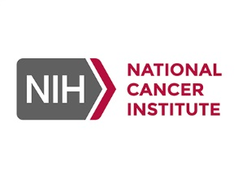
National Cancer Institute
Phone Number: 1-800-422-6237 / 1-800-4-CANCER
Hours: Mon-Fri 9am – 9pm
Email: NCIinfo@nih.gov
Website: www.cancer.gov

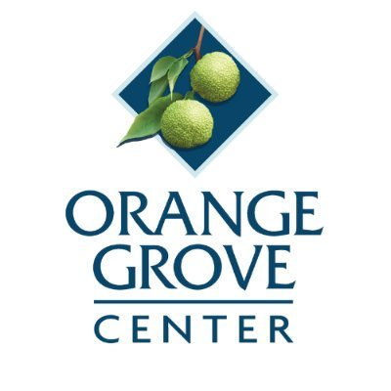
Orange Grove Center
Address: 615 Derby St. Chattanooga, TN 37404
Phone Number: 423-629-1451
Website: www.orangegrovecenter.com
Email: development@orangegrove.org
Hours: Mon- Fri 8am – 4pm

Orange Grove's services and programs are designed to meet the needs of the whole person, from health and dental care; residential and transportation; training and employment; to enrichment services and retirement services.


Project Access Health Initiative
Address: 1917 E 3rd St. Chattanooga, TN 37404
Phone Number: 423-826-0269
Hours: Monday - Thursday 8:30am – 5pm; Friday 8:30am – 4pm

Services Provided: Project Access provides access to health care for low-income, uninsured residents of Hamilton County. Care is provided through community health centers, volunteer physician specialists, hospitals, and other partners.
Eligibility: Hamilton County residents below 150% of the federal poverty level who have a current health problem, who do not have insurance, and who are referred to Project Access by a participating primary care provider.
Payment Information: Most services are provided at no cost to qualifying individuals.
Payment Information: All services are free and voluntary.

The Sexual Assault Rape Crisis Center (SARC)

Address: 300 East 8th St. Chattanooga, TN 37403

Website: www.partnershipfca.com

Hours: Hotline manned 24/7/365

Populations Served: All victims of sexual assault, male and female, age 13 and older. SACRC is the only provider of this service for adults in Hamilton County. Also serve outlying counties as requested.
Eligibility Requirements: Can provide advocacy services to any victims, regardless of how long it has been since their assault. Forensic exam services can be provided within 72 hours of the assault.
Payment information: There is no charge for any services.

Siskin Hospital for Rehabilitation
Inpatient/Outpatient
Address: 1 Siskin Plaza. Chattanooga, TN 37403
Phone Number: 423-634-1200
Hours: Everyday 7am – 9pm

Outpatient
Address: 1309 Panorama Dr. Suite 103 Chattanooga, TN 37421
Phone Number: 423-634-4260
Hours: Monday - Thursday 8am – 5pm

At Siskin Hospital for Physical Rehabilitation, our goal is to help you get your life back, and as quickly and comfortably as possible. When you insist on Siskin, you and your family gain a knowledgeable network of support professionals who work with you to overcome those challenges and help you discover life beyond disability.

Southside Community Health Center

Address: 3800 Tennesse Ave. Suite 124 Chattanooga, TN 37409
Phone Number: 423-778-2700
Hours: Monday, Tuesday, Wednesday, Thursdays 8am – 5pm
Friday 8am – 4pm

Services Provided: Prenatal care with Centering Pregnancy group prenatal care. Preconception health care. The Centers are comprehensive, multi-specialty primary care facilities offering affordable, accessible, high-quality medical and dental care. Other services include wellness, health education, and disease management programs. The staff includes board-certified or board-eligible professional providers including pediatricians, internal medicine specialists, nurse practitioners, and dentists. Gynecological and obstetrical services provided in conjunction with the University of Tennessee College of Medicine OB/GYN residency program. .
Eligibility: All
Payment Information: Cash, Check, Credit card, Sliding fee scale, Medicaid/TennCare, Medicare, Insurance
Eligibility: Families who have children from birth to two who have specific diagnosed medical conditions or developmental delays (25% delay in two developmental areas, or 40% delay in one)
Payment Information: Free of charge if client is eligible.

Tennessee Early Intervention System (TEIS)

Address: 1501 Riverside Dr. Suite 230 Chattanooga, TN 37406
Phone Number: 423-624-6344
Hours: Monday – Friday 8am – 4:30pm
The Tennessee Early Intervention System (TEIS) is a program that provides services to children ages birth up to age three who have disabilities or other developmental delays. The TEIS program is a critically important program to supporting young children and their families to reach their optimal development.

The Speech and Hearing Center
Address: 2212 Encompass Dr. Suite 148 Chattanooga, TN 37421
Phone Number: 423-498-6999
Hours: Monday – Thursday 8am – 5:30pm
Friday 8am – 5pm
Website: https://speechhearing.com/
The Speech & Hearing Center delivers excellent hearing health care to our patients by providing a full range of cutting edge hearing aid technology, state of the art diagnostic equipment and the gold standard of hearing aid fitting, all at fair and affordable pricing. We are devoted to blending big city technology with our small-town values of honesty, integrity and respect. We save you time and money in the long run by delivering the best overall value for your investment.

Urban League of Greater Chattanooga, INC.

Address: 730 E M.L. King Blvd. Chattanooga, TN 37404
Phone Number: 423-756-1762
Website: www.ulchatt.net
Email: info@ulchatta.net
Hours: Monday - Friday 8:30am – 5pm

Impacting students and adults, the ULGC’s Health and Quality of Life program helps uninsured individuals and families access health care resources, such as free or low-cost health clinics, prescriptions, and eye glasses. The ULGC also offers the FIT for Life program, which was launched to reduce the prevalence of obesity and diabetes among urban youth by offering fitness and nutrition classes to children in grades 3-5 at three urban elementary schools.


VIM (Volunteers in Medicine)
(Free medical care for those with no insurance)
Address: 5705 Marlin Rd. Suite 1400Chattanooga, TN 37411
Phone Number: 423-855-8220
Website: www.vim-chatt.org
Hours: Monday – Wednesday 9am – 4pm
Thursday & Friday – CLOSED and unstaffed

The VIM Clinic is open three days a week, Monday - Wednesday. Clinic services are by appointment only. Through its volunteer licensed medical professionals, VIM provides primary and preventive care to financially eligible patients of Hamilton and surrounding counties in Tennessee and Georgia. VIM also helps eligible patients obtain needed medications and advanced care.

Welcome Home of Chattanooga
Address: 400 S Germantown Rd. Chattanooga, TN 37411
Phone Number: 423-355-5842
Website: www.welcomehomeofchattanooga.org

Welcome Home of Chattanooga’s mission creates a community of hope, healing, and compassion for those who are facing a serious illness or death and need safe shelter. They provide shelter and loving care, partnering with area hospices who provide the professional medical care.

WIC (Women’s, Infants and Children)
Address: 921 E 3rd St. Chattanooga, TN 37403
Phone Number: 423-209-8050
Hours: Monday, Wednesday, Thursday 8am – 4pm
Tuesday 8am – 6pm
Friday 9am – 4pm

WIC is a program that offers nutrition education, breastfeeding education and support, nutritious foods, and health referrals to women, infants, and children who qualify.

HOUSING NEEDS

AIM Center Housing
Address: 472 W. Martin Luther King Blvd. Chattanooga, TN 37402
Phone Number: 423-624-4800
Website: www.aimcenterinc.org
Hours: Monday - Friday 8am – 4pm

AIM Center Housing manages 74 safe and affordable housing units for low-income individuals successfully managing their mental illness. AIM Center Housing also provides support services which assist tenants’ development of independent living skills. Residents focus on recovery and growth through decision-making that supports successful management of their mental illness. Meaningful relationships and resource navigation are benefits of living in AIM Center Housing. AIM Center Housing opportunities include shared apartments, private units, and family housing. AIM Center Housing maintains a waiting list of prospective tenants in accordance with HUD and Fair Housing guidelines.

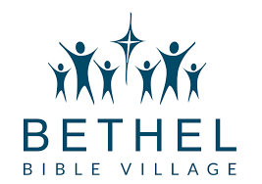
Bethel Bible Village
Address: 3001 Hamill Rd. Hixson, TN 37343
Phone Number: 423-842-5757
Website: www.bethelbiblevillage.org
Hours: 8am – 5pm

Bethel Bible Village provides healing and hope for children and families in crisis. Bethel serves children and families in crisis according to their specific needs. They offer full-time residential care in cottages on their Hixson campus, transitional housing for those 18+, as well as help for families who are struggling with relationship problems. Their programs for youth include: Individual and group counseling, Social work services, Equine and pet therapy, Christian spiritual guidance, Accredited campus school (Bethel Christian Academy)

CADAS (Family Way)
Address: 105 Devel Lane Chattanooga, TN 37405
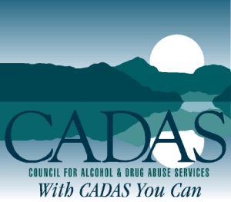
Phone Number: 423-756-7644
Email: Beth.west@cadas.org
Hours: Monday, Wednesday, Thursday 12pm – 3pm

Family Way has several closely monitored program requirements all geared toward helping the residents become better parents and productive members of society. Life skills training, as well as individual and group counseling, are provided to aid with family reunification and with relationship problems within the family. In an extra effort to provide day care and educational resources, CADAS also works with other community agencies to help insure every available community asset is utilized.

Family Way has several closely monitored program requirements all geared toward helping the residents become better parents and productive members of society. Life skills training, as well as individual and group counseling, are provided to aid with family reunification and with relationship problems within the family. In an extra effort to provide day care and educational resources, CADAS also works with other community agencies to help insure every available community asset is utilized.

A family coordinator is available to assist the children with their development. Referrals to Early Childhood Intervention, the Head Start Program and other community resources are made to detect developmental delays, speech and hearing impairments.

Family Way is a solid family-based program that offers success to women wishing to gain a substance-free way of life for themselves and their children.


Chattanooga Housing Authority
Address: 801 N Holtzclaw Ave. Chattanooga, TN 37404
Phone Number: 423-752-4893
Hours: Monday - Friday 8:30am – 5pm

This is a federal rent subsidy program funded through the Dept. of Housing and Urban Development and administered by the Chattanooga Housing Authority, or other Authorities and agencies in the region. The program pays all or partial rent for low-income voucher- (or certificate-) holders who must find a private landlord willing to accept monthly payments from government. In Chattanooga, applicants must be (1) verifiably homeless (through no fault of their own), or disabled and receiving Social Security Insurance, or (2) living in seriously substandard housing, or (3) low-income and working for at least 6 months. The waiting time for this last group is very long.


CNE (Chattanooga Neighborhood Enterprise)
Address: 1500 Chestnut St. Chattanooga, TN 37408
Phone Number: 423-756-6201
Website: www.cneinc.org
Hours: Monday - Friday 9am – 5pm

A government-backed housing agency that helps homeowners who are behind on their mortgage or who are facing a foreclosure. They also help low income families buy a home through savings account, advice, and low cost loans.

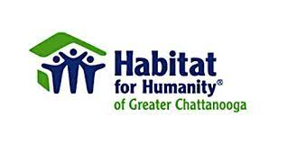
Habitat for Humanity
Address: 1201 E Main St. Chattanooga, TN 37408
Phone Number: 423-756-0507
Website: www.habichatt.org
Hours: Monday - Friday 9am – 5pm
Saturday 9am – 4pm

If your family is in need of decent, affordable housing, apply for homeownership with the Habitat for Humanity. Anyone can apply to be a homeowner. You will be selected based on your level of need, your willingness to partner with Habitat, and your ability to repay a mortgage through an affordable payment plan.

Shepherd’s Arms Rescue Mission
Address: Chattanooga, TN 37416
Phone Number: 423-821-8363
Website: www.shepherdsarms.org
Hours:

Shepherd’s Arms is a Transitional Christ-Centered Shelter for Homeless Women with Children and not an emergency shelter. The difference being our residents may stay with us 4 to 6 months or longer if necessary. Over 1200 homeless women with children have resided at Shepherd’s Arms with 60+% being placed into permanent housing. The goal of restoring dignity and self-worth according to Biblical principles is supreme with evangelism and depth of Christian Discipleship being a vital part of the process.

Intake is done by an initial phone interview followed by an on-site visit and tour. Shepherd’s Arms does not accept women who are at-risk because our shelter is not a hidden shelter. Applicants with a recent history of substance abuse are referred to a more appropriate placement. Shepherd’s Arms only accepts women with children. Residents leave the shelter at 7 a.m. daily and return at 6 p.m. and are asked to be productive by seeking employment, attending school, or actually working while in residence.

Residents are provided three meals daily and a small weekly spending allowance that they are required to budget. They also receive clothing, personal hygiene items, bus passes or gas allowances.

The Home Place (Catholic Charities of East Tennessee)
Address: 5720 Uptain Rd. Building 6100, Suite 4800 Chattanooga, TN 37411
Phone Number: 423-698-9079
Email: krisie@ccetn.org (Krisie Long-Withey)
Hours:
The Home Place is a residential facility that provides a stable, healthy environment and intensive case management services for individuals who are homeless with limited income who are living with HIV/AIDS. Located in a convenient part of Chattanooga, the Home Place is close to hospitals and doctors’ offices, and is on the bus line to allow clients to be as independent as possible within a safe and home-like environment.
LEGAL AID AND TAX

American Civil Liberties Union of TN
Address: P.O. Box 120160 Nashville, TN 37212
Phone Number: 615-320-7142
Website: www.aclu-tn.org

The American Civil Liberties Union of Tennessee (ACLU-TN) is dedicated to translating the guarantees of the Bill of Rights into reality for all Tennesseans. We are an enduring guardian of justice, freedom, fairness and equality, working to protect and advance civil liberties and civil rights for all Tennesseans. Our goal is to preserve the Bill of Rights for future generations.

Hamilton County Child Support
Address: 1221 E Main St. Chattanooga, TN 37408
Phone Number: 423-209-5970

IRS (Internal Revenue Service)
Address: 5740 Uptain Rd. Chattanooga, TN 37411
Phone Number: 423-855-6098
Hours: 8:30am – 4:30pm


Legal Aid of East TN
Address: 535 Chestnut St. Suite 360 Chattanooga, TN 37402
Phone Number: 423-756-4013
Website: www.laet.org

The mission of Legal Aid of East Tennessee is to ensure equal justice for elderly, abused, and low-income people by providing a broad scope of civil legal assistance and advocacy. LAET provides civil legal representation to East Tennesseans who would otherwise have no one to help them secure their basic legal rights.
LEGAL MATTERS

Alternative Sentencing Program
Address: 6215 Dayton Blvd. Hixson, TN 37342
Phone Number: 423-847-4830
Fax: 423-847-4837
Hours: Monday – Friday 8am – 4pm
Website: http://www.hamiltontn.gov/Department_ASP.aspx

Chattanooga City Court
Address: 600 Market St., Room 104, Chattanooga, TN 37402
Phone Number: 423-425-6311
Fax: 423-643-7587
Hours: Monday – Friday 8am – 4pm

Collegedale Municipal Court
Address: 4910 Swinyar Dr. Collegedale, TN 37363
Mailing Address: P.O. Box 1880, Collegedale, TN 37315
Phone Number: 423-468-1891
Fax Number: 423-396-3138
Hours: Monday – Thursday 8am – 5pm, Fridays 8am - noon

East Ridge City Court
Address: 1517 Tombras Ave, East Ridge, TN 37412
Phone Number: 423-867-2701
Fax Number: 423-867-2712
Hours: Monday – Friday 8am – 4pm

Hamilton County Chancery Court
Address: 625 Georgia Ave., Room 300, Chattanooga, TN 37402
Phone Number: 423-209-6600
Fax Number: 423-209-6601
Hours: Monday – Friday 8am – 4pm

Hamilton County Circuit Court
Address: 625 Georgia Ave., Room 500, Chattanooga, TN 37402
Phone Number: 423-209-6700
Fax Number: 423-209-6701
Hours: Monday – Friday 8am – 4pm

Hamilton County Criminal Court (Vince Dean, Clerk)
Address: 600 Market St., Room 102, Chattanooga, TN 37402
Phone Number: 423-209-7500
Fax Number: 423-209-7501
Hours: Monday – Friday 8am – 4pm

Hamilton County Sessions Court
Address: 600 Market St., Room 108, Chattanooga, TN 37402
Phone Number: 423-209-7600
Hours: Monday – Friday 8am – 4pm

Hamilton County Juvenile Court
Address: 1600 E. Third St. Chattanooga, TN 37404
Phone Number: 423-209-5100
Fax Number: 423-209-5251
Hours: Monday – Friday 8am – 4:30pm
Judge Philyaw 423-209-5107
Juvenile Court Clerk (Gary D. Behler) 423-209-5250

Hamilton County Juvenile Court – Child Support Division
Address: 1221 E. Main St. Chattanooga, TN 37404
Phone Number: 423-209-5300
Fax Number: 423-209-5971
Hours: 8:30am – 4:30pm

Hamilton County Public Defender’s Office
Address: 720 Cherry St. Chattanooga, TN 37402
Phone Number: 423-209-6771

Red Bank City Court
Address: 3117 Dayton Blvd. Red Bank, TN 37415
Phone Number: 423-874-0055
Fax Number: 423-875-8767
Hours: Monday – Friday 8am – 4pm

Sex Offender Registry
Address: 601 Walnut St. Chattanooga, TN 37402
Phone Number: 423-209-7198
Website: http://www.hcsheriff.gov/cid/sex_offender_reg.php

Soddy-Daisy Municipal Court
Address: 9835 Dayton Pike, Soddy-Daisy, TN 37379
Phone Number: 423-332-5323

Tennessee Probation and Parole
Address: 6112 Shallowford Rd. Chattanooga, TN 37421
Phone Number: 423-634-4663, 423-634-4662
Hours: Monday – Friday 7:30am – 4:30pm

US Probation
Address: 900 Georgia Ave. Chattanooga, TN 37402
Phone Number: 423-752-5193

LIBRARY


Chattanooga Public Library
Address: 1001 Broad St. Chattanooga, TN 37402
Phone Number: 423-643-7700
Website: chattlibrary.org
Hours: Monday – Thursday 9am – 8pm
Friday & Saturday 9am – 6pm

Eastgate Branch
Address: 5705 Marlin Rd. Chattanooga, TN 37411
Phone Number: 423-855-2689
Hours: Monday & Thursday 9am – 6pm
Tuesday, Wednesday, Friday & Saturday 9am – 6pm
Sunday 1pm – 5pm

Northgate Branch
Address: 278 Northgate Mall Dr. Chattanooga, TN 37415
Phone Number: (423) 643-7785
Hours: Monday & Thursday 9am – 6pm
Tuesday, Wednesday, Friday & Saturday 9am – 6pm
Sunday 1pm – 5pm

South Chattanooga Branch
Address: 925 W. 39th St. Chattanooga, TN 37410
Phone Number: (423) 643-7780

Hours: Monday, Thursday, Friday & Saturday 9am – 6am

Tuesday & Wednesday 11am – 8pm

MEDICATION ASSISTED TREATMENT

What is Medically Assisted Treatment (MAT)?

MAT is an effective method of addiction treatment that combines medication and counseling. Examples of MAT are methadone + counseling, buprenorphine + counseling, and naltrexone + counseling.

The goal of MAT is FULL RECOVERY. It has been shown to:

- Improve patient survival
- Increase retention in treatment
- Decrease opiate use and criminal activity in people with addiction problems
- Increase employment success
- Improve birth outcomes in women who have addiction problems and are pregnant

Read more at:
https://www.samhsa.gov/medication-assisted-treatment/treatment


Bradford Health Services Bridge to Recovery Program
Address: 6160 Shallowford Rd. Chattanooga, TN 37421
Phone Number: 800-879-7272
Website: www.bradfordhealth.com

Bradford’s Bridge to Recovery provides counseling and psychosocial support for patients treated by physicians for Opiate dependency. Medication prescribed by community-based physicians can normalize brain chemistry and provide relief from physical cravings. Weekly support group for clients and families.

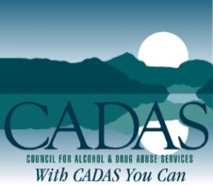
CADAS
Address: 207 Spears Ave. Chattanooga, TN 37405
Phone Number: 423-756-7644
Website: www.cadas.org

CADAS provided a Medically Assisted Treatment Intensive Outpatient Program for clients 18 years or older. Provides long term taper Buprenorphine and counseling or Naltrexone/Vivitrol and counseling.

East Tennessee Recovery
Address: 2408 Susannah St. Johnson City, TN 37601
Phone Number: 423-434-6677
Website: www.restorationandwellness.com

Provides treatment education and hope to those who need help fighting the disease of addiction. Accepts all major insurances.


Frontier Health
Address: 900 Buffalo St. Johnson City, TN 37605
Phone Number: 423-232-4130
Website: www.frontierhealth.com

Services available include detoxification, residential treatment, intensive outpatient and other supportive services.

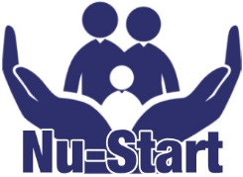
Nu Start
Address: 5721 Marlin Rd. building 6100n Suite 3200 Chattanooga, TN 37411
Phone Number: 423-208-3473
Website: hccoalition.org/nustart-recovery-wraparound

Nu-Start provides access to treatment and recovery services for individuals and families overcoming opioid dependency. Services include access to Individual and Family Counseling, Family Stabilization & Support Services, Recovery Support Services (In-Patient, Out-patient, MAT), Opioid Overdose Reversal Training, and free Naloxone.


Spero Health
Address: 7030 Lee Highway Suite 201 Chattanooga, TN 37421
Phone Number: 423-301-5930
Website: www.sperohealth.com

Spero Health delivers outpatient care to treat patients close to home in their own environments so they can cope with life as they overcome addiction. They create an individualized treatment plan for each patient using a pioneering, proven, three pronged approach of evidenced-based physician services, counseling and recovery support services. MAT treatment includes Suboxone or Vivitrol. Counseling includes individual and/or group sessions.

Volunteer Comprehensive Treatment Center – Acadia Healthcare
Address: 2347 Rossville Blvd. Chattanooga, TN 37408
Phone Number: 423-265-3122
Website: www.chattanoogactc.com

Volunteer Comprehensive Treatment Center is a leading provider of medication assisted treatment for adults, ages 18 and older, providing Methadone/Suboxone and counseling.

MENTAL HEALTH & COUNSELING

AIM Center
Address: 472 W. Martin Luther King Blvd. Chattanooga, TN 37402
Phone Number: 423-624-4800
Website: www.aimcenterinc.org
Hours: Monday - Friday 8am – 4pm

AIM Center offers employment, education, housing, socialization, and wellness opportunities for adults living with serious mental illness. We are non-medical and non-clinical; however, we work with other mental health professionals to provide comprehensive mental health services.

Behavioral Health Safety Net

The Behavioral Health Safety Net for Adults provides essential mental health services to people who are uninsured, underinsured, or have no means to pay.

They provide services to include: Assessment and evaluation, Case Management, Psychiatric Medication Management, Psychosocial Rehabilitation Services, and Therapeutic Interventions.

In order to be eligible for services, you must have a primary qualifying mental health diagnoses, have no other behavioral health coverage, have income at or below 138% FPL, be 18 years of age or older and be a Tennessee resident.

They offer outpatient services only. It is not insurance or part of TennCare. Behavioral Health Medication is provided through CoverRx.

Services can be obtained through Mental Health Cooperative, Volunteer Behavioral Health, and Helen Ross McNabb.

Erlanger Behavioral Health

Address: 804 N. Holtzclaw Ave. Chattanooga, TN 37404

Phone Number: 423-834-7176

Website: erlangerbh.com

Hours: Open 24/7

Provides acute psychiatric care to suit a patients’ needs. Expert staff members understand the unique needs of patients at various life stages and build treatment plans that reflect each individual’s strengths and challenges on the journey to recovery.


Health Connect America (IOP)

Address: 2115 Chapman Rd. #115, Chattanooga, TN 37421

Phone Number: 423-702-5508

Website: www.healthconnectamerica.com

Hours: Monday – Friday 9am – 5pm

Services Provided: Intensive in-home, outpatient mental health, psychiatric clinical, substance use disorder, supervised visitation, and therapeutic foster care. Services are covered by TennCare, Blue Cross Blue Shield of Tennessee, and by sliding scale fee.

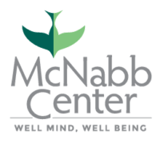
The McNabb Center – Hamilton County Adult Center (Outpatient Services)

Address: 601 Cumberland St. Chattanooga, TN 37404

Phone Number: 423-266-6751

Hours: Monday – Friday 8am – 5pm

Services Provided: Outpatient mental health services, Counseling/therapy, Alcohol and drug intensive outpatient services, Case management. Homeless Services.
Eligibility: TennCare, Commercial insurance, Cover kids
Payment Information: Varies depending on coverage plan.

Johnson Mental Health Center (Outpatient Services)
Address: 420 W Bell Ave. Chattanooga, TN 37405
Phone Number: 423-634-8884
Hours: Monday - Friday 8am – 5pm
Website: www.vbhcs.org/locations/chattanooga

Outpatient treatment for co-occurring disorders, outpatient counseling, care coordination, medication assessment and medication management for co-occurring disorders

Mental Health Cooperative of Chattanooga (IOP) *financial assistance available
Address: 801 North Holtzclaw Ave. Suite 101 Chattanooga, TN 37404
Phone: 423-697-5950
Website: mhc-tn.org

Mobile Crisis Response
Phone Number: 800-223-4512
Hours: Monday – Friday 8:00am – 4:30pm

Services Provided: Provide psychiatry, therapy, and case management for anyone ages 3 and older. Each person is assigned a case manager and then sees an intake clinician who does an evaluation to determine necessity of care. If the person has ongoing mental health needs he/she is then recommended for services (psychiatry or therapy) as appropriate or given referrals to another agency if ours isn't appropriate. We have an open door policy, and this is a place of relationship building and dignity. We share all our amenities with our consumers and strive to provide a welcoming and comforting atmosphere.
Populations Served: Anyone over the age of 3 that meets eligibility requirements.
Eligibility: Anyone Aged 3 yrs. or older with TennCare or on the Behavior Health Safety Net.
Payment Information: TennCare or Safety Net Eligible. No cash, no private insurance and no sliding scale.

Moccasin Bend Mental Health Institute (Inpatient)

Address: 100 Moccasin Bend Rd. Chattanooga, TN 37405

Phone Number: 423-265-2271

Website: tn.gov/behavioral-health/hospitals/moccasin-bend.html

Hours: 24 hours a day

Moccasin Bend Mental Health Institute assists patients who are not typically served by the private service sector and have no other inpatient treatment resources available to them. Most patients have a severe and persistent mental illness and are hospitalized on an emergency, involuntary basis. The hospital is an authorized provider under TennCare.
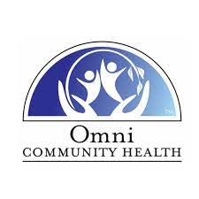

Omni Community Health (Outpatient)

Address: 1401 Williams St. Suite 210 Chattanooga, TN 37408

Phone Number: 865-524-4399

Website: theomnifamily.com/behavioral-health

Hours:

Omni Community Health is a comprehensive outpatient behavioral health organization providing innovative, quality programs to heal children, families, and adults. Offering state-of-the-art, evidence-based approaches that include a focus on trauma competent care – all designed to acknowledge life’s adversities, honor resiliency, and empower clients to find the next step in their ongoing journey to healing.

Parkridge Valley Adult & Senior Campus (Residential and IOP)

Address: 7351 Courage Way Chattanooga, TN 37421

Phone Number: 423-894-4220

Website: parkridgehealth.com/service/behavioral-health

Parkridge Valley Adult and Senior Campus serves adults and seniors needing assistance with behavioral health and/or chemical dependency issues (including drug and alcohol) in both an inpatient and outpatient setting, PHP, IOP—day and night.

The Lighthouse

Address: 509 S. Highland Park Chattanooga, TN 37404

Phone Number: 1-800-255-9711

The Lighthouse offers a peer support program. The program is designed to provide opportunities for adults with a mental illness to develop social skills in a community setting.

NUTRITIONAL INFORMATION
Chattanooga Fitness Center at Warner Park
Address: 1254 E 3rd St. Chattanooga, TN 37404
Phone Number: 423-697-1320
Hours: Monday - Thursday 8am – 8pm
Friday 8am – 7pm
Saturday 8am – 12pm

Hamilton County Health Department Nutrition Services
Address: 921 E 3rd St. Chattanooga, TN 37403
Phone Number: 423-209-8000
Website: http://www.hcstep1.org/
Hours: Monday, Wednesday, Thursday, Friday 8am – 4pm
Tuesday 8am – 6pm

Step ONE (Optimize with Nutrition and Exercise) is a collaboration between the Chattanooga-Hamilton County Health Department, the Hamilton County Mayor’s Office, and the Hamilton County Regional Health Council that was started in 2004. Our mission is “To create a culture of health in Hamilton County where residents choose to eat healthy and be physically active.”
You are encouraged to participate with Step ONE by eating healthier, being more physically active, and supporting your neighbors, family, friends, and co-workers with their efforts as well.
For more information, call Step ONE at (423) 209-8090

UT/TSU Extension
Address: 6183 Adamson Cir. Chattanooga, TN 37416
Phone Number: 423-855-6113
Website: https://hamilton.tennessee.edu/nutrition-education/
Hours: Monday - Friday 8am – 4:30pm
Email: jhartma1@tnstate.edu (SNAP Education Program) or aolson@utk.edu (EFNEP Education Program)

UT Extension’s Department of Family and Consumer Sciences delivers research-based education across Tennessee to help families choose and prepare foods that lead to healthy eating patterns.

We offer two Nutrition Education programs in Hamilton County, both focusing on teaching families and individuals how to prepare healthy meals on a budget.

The Supplemental Nutrition Assistance Program (SNAP) Education Program provides nutrition education and obesity prevention education for persons eligible for SNAP benefits. Using a series of hands-on lessons, the program teaches clients about good nutrition and how to make their food dollars stretch further, as well as how to be more physically active. Participants learn to shop, cook and eat on a budget.

The Expanded Food and Nutrition Education Program (EFNEP) is a peer-to-peer direct, hands-on nutrition education program designed to reach adults who are caregivers of young children as well as school-age youth at risk for food insecurity. The purpose of EFNEP is to help limited-income families and youth acquire the knowledge, skills, and attitudes to form healthy eating habits that result in optimal health.


PARENTING RESOURCES
Baby and Me Tobacco Free
Address: 921 E. 3rd St. Chattanooga, TN 37403
Phone Number: 423-209-8182
Hours: Monday – Friday 8:00am – 4:00am

Service Provided: Support and educational materials provided to pregnant women who are current smokers to enable them to stop. Four educational/support sessions are provided during the prenatal period, client is supported to set a quit date and tools to aid her in her decision and success to quit are provided. Client is tested with carbon monoxide detector at each visit to determine if she is smoke free. After delivery, client will receive a $25 diaper voucher each month that she is smoke free for 12 months.
Populations Serviced: Prenatal and Postpartum women who are smokers with a desire to quit. Services are provided at several Health Department clinic sites.
Eligibility Requirements: Hamilton county resident, pregnant, smoker
Payment: Free of charge.
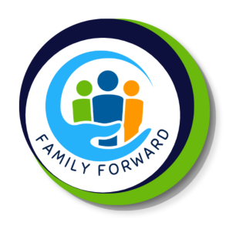
Family Forward (Mentoring for Expectant Mothers)
Address: 109 N Germantown Rd. Chattanooga, TN 37411
Phone Number: 423-698-8528
Website: babyuchattanooga.org
Hours: Monday – Friday 8:30am – 4:30pm

Services Provided: Intensive case management, resource linkage, education, mentoring, support, parent workshops, and family activities. Target communities include East Lake, East Chattanooga, and Alton Park (some exceptions may be made).
Populations Served: Pregnant families and those with children under 2 years of age.
Eligibility: Must be pregnant or have a child under 2 years old. Please call for details.
Payment Information: All services are free and voluntary.

Catholic Charities

Address: 5720 Uptain Rd. Building 6100 Suite 4800 Chattanooga, TN 37411
Phone Number: 423-826-0673
Pregnancy Helpline – 24 hours - 877-990-4673
Website: https://ccetn.org/pregnancy-help
Email: phc@ccetn.org
Hours: Monday – Friday 10am – 4pm

The Pregnancy Help Center offers Earn While You Learn educational credits redeemable for infant or even toddler items. Credits can be used for daily needed infant supplies, as well as larger ticket items, such as car seats, cribs, etc. Earn While You Learn is an evidence based program and an excellent opportunity to learn about your pregnancy and improve parenting skills while earning the material items needed along the way!

Choices Pregnancy Resource Center (East Chattanooga Location)

Address: 6232 Vance Rd. Chattanooga, TN 37421
Phone Number: 423-892-0803
Website: www.choiceschattanooga.org
Hours: Monday, Tuesday, Friday 9am – 4pm
Wednesday 10am – 4pm
Thursday 9am – 7pm

If your pregnancy was not planned and you’re considering parenting, you may have more questions than answers about birth, baby care and parenting.

Choices is here to help you take the time to address your parenting concerns and help you find the resources you need. If you’re not sure if parenting is the right choice for you, we are happy to help you explore all your options.

Many people who want to parent may have questions and concerns about single parenting, continuing their education, financial stability and other topics.

Christian Women’s Job Corps of Chattanooga
Address: 401 Gateway Ave. Chattanooga, TN 37402
Phone Number: 423-305-6200 – Contact Caroline Jones
Website: http://cwjc-chattanooga.com/events/
Hours: Mondays 5:30pm – 8pm
CWJC offers Parenting Classes for 7 weeks of classes teaching parenting skills acceptable to the Department of Children’s Services. Women have to be 18 and over, drug free and ready to move forward in her life.
Erlanger Safe and Sound
Address: 910 Blackford St. Chattanooga, TN 37403
Phone Number: 423-778-6691
Website: https://www.childrensaterlanger.org/childrens-hospital/patient-family-resources/injury-prevention/safe-and-sound
Office Hours: Call for an appointment

Services Provided: Injury prevention services: car seat safety, toy safety, bicycle safety
Payment Information: Free (donations are welcomed)
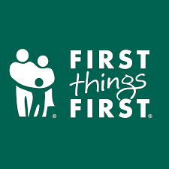
First Things First
Address: 620 Lindsay Street, Suite 100 Chattanooga, TN 37403
Phone Number: 423-267-5383
Website: www.firstthingsfirst.org


Resources for new and soon-to-be parents with specific classes created for married couples, unmarried couples and fathers.

Fortwood Center
Address: 601 Cumberland St. Suite A Chattanooga, TN 37404
Phone Number: 423-266-6751

The McNabb Center offers parenting classes. Call us at 1-800-255-9711 to learn more about signing up for these classes.

Healthy Families TN
Address:
• 601 Cumberland St. Chattanooga, TN 37404
• 6055 Shallowford Rd. Chattanooga, TN 37421
Phone Number: 423-266-6751

Services Provided: In-home education; support services and parent coaching.
Populations Served: Pregnant/ postpartum women and children up to age 5.
Eligibility: First time parents (prenatal and postnatal) with a baby under 3 months of age, or mothers under 21 years of age with multiple children.
Payment Information: There is no charge. Services provided free with no income guidelines.

Healthier Beginnings – Parents Are First Teachers (HB/PAFT)
Address: 921 E 3rd St. Chattanooga, TN 37403
Phone Number: 423-209-8080 / 423-209-8298
Website: www.parentsasteachers.org
Hours: Monday – Friday 8am – 4pm

Healthier Beginnings/PAFT is home based program which focuses on parenting skills, early childhood development and school readiness, as well as the health and wellness of family members. Services can begin prenatally or postpartum and continue for a child through age 5 years. Participating families can expect to receive:
- personal teaching visits
- health and development monitoring and education
- monthly opportunity to meet with other parents for fun and educational activities
- connections and referrals to other needed services

Partnership for Families, Children and Adults
Address: 1800 McCallie Ave. Chattanooga, TN 37404
Phone Number: 423-755-2700
Website: www.partnershipfca.com
Email: bwalker@parnershipfca.com
Hours: Monday – Friday, 8:30am - 4:30pm

Services Provided: The Parenting Education Program provides case management and home visitation services for pregnant and parenting teens and young adults, including education on prenatal and postnatal care, nutrition, child development, contraception, abuse prevention, and community resources.
Populations Served: Infants/ children, Teens, Women, Pregnant women, Families
Eligibility: Teens and young adults who are pregnant or have a young child.
Payment Information: Free of charge


Nurture the Next
Address: 4721 Trousdale Dr. Suite 121 Nashville, TN 37220
Phone Number: 615-383-0994
Hours: Monday - Friday 8:30am – 4:30pm

Our programs build these relationships and safe environments for children in both their families and their communities. The goal of each of our programs is to reduce traumatic experiences resulting from adult behavior and environments that can weaken a child’s foundation. This requires a two-generation approach that supports the wellbeing of parents and children.

Participation in our programs is always voluntary, free and confidential.
Home Visiting
Extended support offered through weekly home visits for parents from pregnancy through when their child enters kindergarten.
Parenting Classes
Concentrated parenting support provided over 8-12 weeks for parents with children age 12 and under. This program is ideal for families facing situations that impact their ability to parent.
Parent Mentorship
Parent-to-parent mentorship designed for new moms to ask questions and receive information using text messages.
WIC: Women, Infants & Children
Address: 921 E. 3rd St. Chattanooga, TN 37403
Phone Number: 423-209-8220
Hours: Monday – Friday, 8:00am – 4:00pm

WIC is a program that offers nutrition education, breastfeeding education and support, nutritious foods, and health referrals to women, infants, and children who qualify.

RECOVERY HOUSING / RESIDENTAL TREATMENT PROGRAMS

Adult & Teen Challenge (Men and Women)
Mid-South Adult Center
Address: 1108 W. 33rd St. Chattanooga, TN 37410
Phone: 423-756-5558
Website: teenchallengeusa.org

Adult & Teen Challenge MidSouth’s Journey from Addiction to Freedom is a 3-Tier strategy overcoming life-controlling addiction. The addiction may involve a chemical substance or merely a habit that undermines someone being able to achieve their God-given purpose in life.

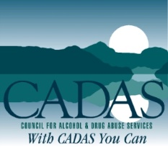
CADAS/Family Way/Oasis
Address: 207 Spears Ave. Chattanooga, TN 37405
Phone: 877-282-2327
Website: www.cadas.org

Long-term permanent furnished housing units.

Family Way - Supportive Housing for women and children (1-2 years)
Treatment, support, and life skills. Accepts pregnant women and their children under 12.

Focus Treatment Centers
Address: 7429 Shallowford Rd. Chattanooga, TN 37421
Phone: 800-675-2041 / 423-308-2560
Website: https://focustreatmentcenters.com/

Focus Treatment Centers offers treatment and advocacy for adults struggling with substance addictions, or those with dual diagnoses. Our Whole Person Treatment approach applies to inpatient detoxification, residential, partial hospitalization (PHP) and intensive outpatient (IOP). Focus Treatment Center offers 12-programming alongside holistic therapeutic modalities. Focus Treatment Centers is in network with most major insurance companies.


House of Refuge (Men)
Address: 3418 Saint Elmo Ave. Chattanooga, TN 37409
Phone: 423-760-7372
Website: http://www.chattanoogahouseofrefuge.org/

A Christ-centered residential ministry primarily helping African-American men overcome their life-controlling addictions so they can successfully re-enter society as productive society.
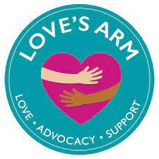
Love’s Arm (Women)
Address: P.O. Box 21488 Chattanooga, TN 37424
Phone: 423-580-6553
Website: www.lovesarmoutreach.org/
Email: info@lovesarmoutreach.org

Provides residential, 12-step programs for persons in addiction-related prostitution and the sex industry.
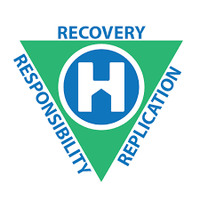
Oxford House (Men and Women)
Address: 1010 Wayne Avenue Suite 300 Silver Spring, MD 20910
Phone: 800-689-6411
Website: www.oxfordhouse.org

There are currently 21 houses in Hamilton County – 14 male houses and 7 female houses.

Oxford House is a concept in recovery from drug and alcohol addiction. In its simplest form, an Oxford House describes a democratically run, self-supporting and drug free home. The number of residents in a House may range from six to fifteen; there are houses for men, houses for women, and houses which accept women with children.

Renew Ministries (Men and Women)
Address: 3415 Broad St. Chattanooga, TN 37409
Phone: 423-840-0053
Website: https://calvarychatt.com/renew
Office Hours: Wednesday – Friday 9am – 5pm

Renew is a faith-based ministry that is designed to restore women to the place of dignity and contribution in society that God designed them to have. The mission is to help women break addictive and destructive life patterns through a personal relationship with Jesus by learning how to use His Word to change their thinking, which results in different life choices that bring actual life transformation and not just behavioral transformation and not just behavior modification.
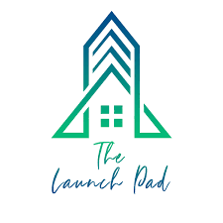
The Launch Pad (Women)
Address: Chattanooga, TN 37405
Phone: 423-902-4822
Website: thelaunchpadchattanooga.org

The Launch Pad is a temporary home for women recovering from substance abuse. We provide a positive, friendly environment that is geared toward allowing a woman to once again return to society and be happy, healthy and productive.

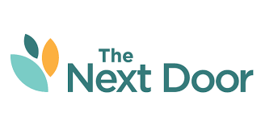
The Next Door (TDOC Women)
Address: 108 Moccasin Bend Chattanooga, TN 37405
Phone: 423-933-0112
Website: https://thenextdoor.org/locations/chattanooga/

The Next Door Chattanooga prepares women for independent living free from drug and alcohol abuse.

The Next Door Chattanooga offers a unique program in partnership with the Tennessee Department of Correction. Women served by The Next Door at the Chattanooga location are currently incarcerated, and receive transitional services rooted in evidence-based practices to address the needs of the women.

Prior to release from incarceration, women are transported from prison to The Next Door Chattanooga’s Correctional Release Center. While at the Correctional Release Center, women work toward gaining job and life skills that will assist in a productive re-entry into society. This Correctional Release Center is the first of its kind for the State of Tennessee and Department of Correction, and is designed to equip these women for independent living, free from drug and alcohol abuse.


Union Gospel Mission (Men’s, faith-based, residential program)
Address: 124 Signal Hills Dr. Chattanooga, TN 37405
Phone: 423-752-4998
Website: theuniongospelmission.org
Email: mail@theuniongospelmission.org

The G.R.A.C.E. Discipleship Program is designed to be a six month, residential, program for men seeking to address “life-controlling” issues in their lives. The majority of clients in this program come from a background of drug addiction and/or alcoholism. This program will also help address other issues of addiction and/or a life of poor decision making.
A curriculum that combines group classes, self-study, daily structure, and strong personal accountability; provides the necessary tools for our clients to achieve the change in their lives that they seek.

Once our clients have completed the G.R.A.C.E. Discipleship Program, we have found that the majority of them are in need of a “next step”. For those who don’t have a support system in place, we provide them with housing, help with job search, budgeting, and re-integrating into “normal” society.
Our After-Care program provides that “extra step” in helping our clients transition into a productive life.

SPECIAL NEEDS HELP FOR CHILDREN
Chattanooga Autism Center
Address: 1400 McCallie Ave. Suite 1-00
Chattanooga, TN 37404
Phone Number: 423-531-6961
Website: www.chattanoogaautismcenter.org
Hours: Monday – Friday 9am – 4pm
Non-profit parent-driven center providing lifespan support and services for people with autism spectrum disorders and their families.

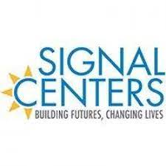
Signal Centers INC.
Address: 109 N Germantown Rd. Chattanooga, TN 37411
Phone Number: 423-698-8528
Website: https://www.signalcenters.org/
Hours: Monday – Friday 7:30am – 5:30pm

At Signal Centers, we recognize that each child who enters our program is special and has a unique set of strengths and needs. We serve children with a variety of developmental delays and disabilities as well as children without disabilities or delays, and we are proud of our inclusive classrooms. We know that our integrated approach to therapy and related services has a positive outcome for all children in the classroom.

In accordance with each child’s Individualized Educational Program (IEP) or Individualized Family Service Plan (IFSP), specific therapeutic needs are addressed for each child enrolled. Speech/Language Therapy, Physical Therapy, Occupational Therapy, Vision Therapy, Feeding Therapy (for those enrolled in Early Intervention classes), Behavioral Intervention, and Nursing Services support the teaching and learning in the classroom.
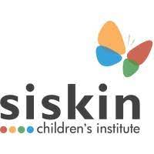
Siskin Children’s Institute
Address: 1101 Carter St. Chattanooga, TN 37402
Phone Number: 423-648-1700
Email: info@siskin.org
Website: siskin.org/www
Hours: Monday – Friday 8am – 5pm

Education
The Siskin Early Learning Center provides a high quality preschool education to young children with and without disabilities, including children with developmental delays, autism spectrum disorder, chromosomal abnormality and brain injury. All children learn and play side-by-side in an environment that celebrates the accomplishments of every child.
Health Care
The Siskin Center for Developmental Pediatrics is a regional developmental pediatric center, led by a team of developmental pediatricians, with services available in Chattanooga and Nashville, TN. Children are referred to the Institute for medical, psychological and cognitive assessment, diagnosis and therapies, including occupational, speech and language, feeding, and applied behavior analysis.
Home Visiting
The Siskin Home & Community-Based Early Intervention program is designed to help parents, other caregivers and children with special needs gain the knowledge and confidence they need to be successful in life. Through visits with a developmental therapist, the family receives information, support, guidance and consultation about improving the child’s and family’s quality of life. It’s a program that can be provided in the home, child care center, the park or other natural settings in the community.
Outreach
Siskin Outreach Services provide disability information to families, college students and professionals through a dynamic array of programs that weave through the Institute’s other areas of focus. Outreach Services houses the Helen Siskin Pregulman Family Voices of Tennessee Southeast Partnership program, offering a lending library, family support and training, consultation services, and professional training in fields related to special needs, and early childhood development.

Tennessee Early Intervention System (TEIS)
Address: 1501 Riverside Dr. Suite 230 Chattanooga, TN 37406
Phone Number: 423-624-5344
Hours: Monday - Friday 8am – 4:30pm

The Tennessee Early Intervention System (TEIS) is a program that provides services to children ages birth up to age three who have disabilities or other developmental delays. The TEIS program is a critically important program to supporting young children and their families to reach their optimal development

The Speech and Hearing Center
Address: 2212 Encompass Dr. Suite 148 Chattanooga, TN 37421
Phone Number: 423-498-6999
Website: www.speechhearing.com
Hours: Monday – Friday 8am – 5:30pm

The Speech & Hearing Center delivers excellent hearing health care to our patients by providing a full range of cutting edge hearing aid technology, state of the art diagnostic equipment and the gold standard of hearing aid fitting, all at fair and affordable pricing. We are devoted to blending big city technology with our small-town values of honesty, integrity and respect. We save you time and money in the long run by delivering the best overall value for your investment.

TN Department of Health, Children’s Special Services
Address: 311 E M.L. King Blvd. Chattanooga, TN 37403
Phone Number: 423-634-6319

The Children's Special Services (CSS) Program may provide coverage for comprehensive medical care and other non-medical resources for children with physical disabilities and special health care needs from birth to 21 years of age.

The medical services component provides for reimbursement of medical services, i.e., physician/clinic visits, hospitalizations, medical supplies, pharmaceuticals, durable medical equipment, and therapies for children who meet medical and financial eligibility requirements.

The care coordination component assists families of eligible children with coordinating primary and specialty care through the designated primary care physician and corresponding managed care organization networks. Care coordinators assist the family in accessing many services (educational, medical, social, transportation, support and advocacy).
SUPPORT GROUP SERVICES

Alcoholics Anonymous Chattanooga Area Central Office
Address: 5611 Ringgold Rd. Suite 130 Chattanooga, TN 37412
Phone Number: 423-499-6003 (Answered 24/7 by AA members)
Website: www.chattanooga-aa.com
Hours: Monday - Friday 9am – 5pm
Alcoholics Anonymous is a fellowship of men and women who share their experience, strength and hope with each other that they may solve their common problem and help others to recover from alcoholism.
Celebrate Recovery (Christian 12 Step)

Phone: 423-309-4254
Website: www.celebraterecovery.com

Christ-Centered 12-step program. Celebrate Recovery is a "large umbrella" 12 Step program to help a limitless number of issues. It is a biblical and balanced program effective in helping people overcome their hurts, hang-ups and habits. Many of the addiction issues we deal with include alcohol addiction, drug addiction, gambling addiction, sexual addiction and food addiction. We also deal with eating disorders, love and relationship addiction, co-dependency, and anger to name a few.

Hospice of Chattanooga (Bereavement)

Address: 4411 Oakwood Dr. Chattanooga, TN 37413
Phone Number: 423-892-4289
Website: Hospiceofchattanooga.org

Hospice of Chattanooga offers a wide range of grief support services, including group counseling sessions. We are proud to provide these support group services free of charge to any person in need of grief counseling in our service area. You do not need to be connected to a patient of Hospice of Chattanooga to attend our support groups, and any person working to cope with the death of someone close to him or her is invited to attend.

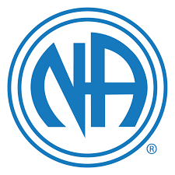
Narcotics Anonymous
Phone Number: 888-463-2117
Website: www.nachattanooga.com
Anyone who wants to stop using drugs may become a member of Narcotics Anonymous. Membership is not limited to addicts using any particular drug. Those who feel they may have a problem with drugs, legal or illegal, including alcohol, are welcome in NA. Recovery in NA focuses on the problem of addiction, not on any particular drug.

Overeaters Anonymous
Phone Number: 423-894-9966
Website: https://oa.org

Overeaters Anonymous (OA) is a community of people who support each other in order to recover from compulsive eating and food behaviors. They welcome everyone who feels they have a problem with food.

Partnership for Families, Children and Adults Domestic Violence Support Group
Phone Number: 423-755-2822
Meetings: Thursdays 6:30pm – 7:30pm

Partnership for Families, Children and Adults Rape Crisis Center
Address: 300 E 8th St. Chattanooga, TN
Phone Number: 423-755-2700

Pendulum Club Depression
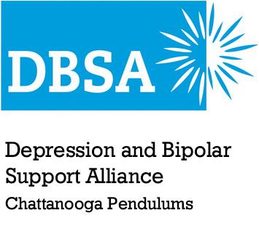
Address: The AIM Center, 472 West M.L. King Blvd, Chattanooga, TN, 37402
Phone Number: 423-504-7172 (Joe Herman, Facilitator)
Website: https://www.dbsachattanooga.org/
Meetings: Thursdays 6:30pm – 8pm

Depression and bipolar disorder can be isolating illnesses. Chattanooga Pendulums support group can help you connect with others who have been there as well. Meetings are always free. We meet weekly on Thursday nights at 6:30PM. Visit us and get the support that is essential to recovery. You will be glad you did! We operate under the guidelines of the National Depression and Bipolar Support Alliance as one of its sanctioned chapters.

Southeast TN Area Agency on Aging and Disability
Address: 1000 Riverfront Pkwy. Chattanooga, TN 37402
Phone Number: 423-424-4256
Website: www.setaaad.org

The mission of the Southeast Tennessee Area Agency on Aging and Disability is to help older adults and people with disabilities live with dignity and choices in their homes and communities.

The Compassionate Friends of Chattanooga

Address: 419 McCallie Ave. Chattanooga, TN 37402 (First Centenary UMC)
Phone Number: 423-942-9206
Website: http://www.compassionatefriendschattanooga.org
Hours: Meetings held on the 2nd Sunday of each month at 3:00 pm Et at First Centenary United Methodist Church, Chattanooga, TN

Services Provided: Support group for parents and grandparents who have suffered the loss of a child of any age or reason.
Eligibility requirements: Bereaved parent or grandparent.
Payment Information: No payment or fee required.
TRANSPORTATION

Care-A-Van (Disabled)
Address: 740 E 12th St. Chattanooga, TN 37403
Phone Number: 423-698-9038
Website: gocarta.org
Hours: Monday – Friday 4:40am – 12:45am
Saturday 5:30am – 12:45am
Sunday 8:00am – 9:00pm
Cost: One Way - $2.50, Round Trip - $5.00

CARTA Care-A-Van service is available to residents and visitors in CARTA's service area who due to injury, illness or functional incapacity of a temporary or permanent nature, are unable to use CARTA's fixed route transit vehicles. Care-A-Van service requires an application and physician's statement to verify eligibility in compliance with the Americans with Disabilities Act (ADA).

Care-A-Van provides lift vans to transport the disabled to needed services such as work, school, recreation, medical services or other essential services. Care-A-Van operates within CARTAS fixed route services hours.
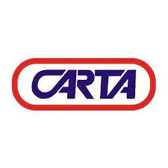

CARTA Bus Service
Address: 1617 Wilcox Blvd. Chattanooga, TN 37406
Phone Number: 423-629-1273
Website: www.carta-bus.org

STS (Special Transit Services)
Address: 740 E 12th St. Chattanooga, TN 37403
Phone Number: 423-698-7337

Southeastrans, Inc.

Address: 5751 Uptain Rd. Suite 300 Chattanooga, TN 37411
Phone Number: 423-893-8282
Email: cmckinney@southeastrans.com

Southeastrans provides services for non-emergency transportation to BlueCare and TennCareSelect members. If you have no way to get to your covered health services, you can call to get a ride.
RECREATIONAL ACTIVITIES

City of Chattanooga Department of Youth and Family Development
Address:

• Avondale Community Center
1305 Dodson Ave.
Chattanooga, TN 37406
Ph: 423-697-1277
• Brainerd Complex
1010 N Moore Rd.
Chattanooga, TN 37411
Ph: 423-643-6220
• Carver Complex
600 N Orchard Knob Ave.
Chattanooga, TN 37404
Ph: 423-697-1280
• East Chattanooga Community Center
2409 Dodson Ave.
Chattanooga, TN 37406
Ph: 423-697-1281
• Cromwell Center
3940 Camellia Dr.
Ph: 423-708-8333
• Eastdale Community Center
1312 Moss St.
Chattanooga, TN 37411
Ph: 423-697-1289
• East Lake Community Center
3601 Dodds Ave.
Chattanooga, TN 37407
Ph: 423-867-4498
• First Centenary Community Center
403 Oak St.
Chattanooga, TN
Ph: 423-266-3345
• Frances B Wyatt (Colville Street) Community Center
406 Colville St.
Chattanooga, TN 37405
Ph: 423-757-5443
• Glenwood Recreation Center
2610 E 3rd St.
Chattanooga, TN 37404
Ph: 423-697-1284
• Hixson Community Center
5401 School Dr.
Hixson, TN 37343
Ph: 423-643-6480
• John A Pattern Recreation Center
3202 Kelly’s Ferry Rd
Chattanooga, TN 37419
Ph: 423-825-5955
• North Chattanooga Community Center
406 May St
Chattanooga, TN 37405
Ph: 423-757-5447
• Westside Community Center
1201 Popular St.
Chattanooga, TN 37402
Ph: 423-756-3541
• Shepherd Community Center
2124 Shepherd Rd.
Chattanooga, TN 37421
Ph: 423-855-2697
• South Chattanooga Swimming
1151 W 40th St.
Chattanooga, TN 7409
Ph: 423-643-6800
• Tyner-East Brainerd Community Center
6900 Ty Hi Dr.
Chattanooga, TN 37421
Ph: 423-855-2664
• Washington Hills Community Center
4628 Oakwood Dr.
Chattanooga, TN 37416
Ph: 423-855-2679

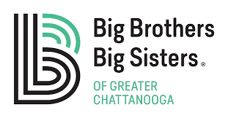
Big Brothers Big Sisters of Greater Chattanooga
Address: 2015 Bailey Ave. Chattanooga, TN 37404
Phone Number: 423-698-8016
Hours: Monday - Thursday 8am – 5pm
Friday 8am – 4:30pm
Website: http://www.bbbschatt.org/

Big Brothers Big Sisters helps children realize their potential and build their futures. They nurture children and strengthen communities. For 63 years, Big Brothers Big Sisters of Greater Chattanooga has operated under the belief that inherent in every child is the ability to succeed and thrive in life. As a member agency of the oldest and largest youth mentoring organization in the United States, we make meaningful, monitored matches between adult volunteers (“Bigs”) and children (“Littles”), ages 6 through 14, in Hamilton County. We develop positive relationships that have a direct and lasting effect on the lives of young people in our community.


Boy Scouts of America Cherokee Area Council
Address: 6031 Lee Highway Chattanooga, TN 37421
Phone Number: 423-892-8323
Website: www.cherokeeareabsa.com
Hours: Monday - Friday 8:30am – 5pm

Our purpose is to provide an educational program for boys and young adults to build character, to train in the responsibilities of leadership and participating citizenship, and to develop personal fitness.

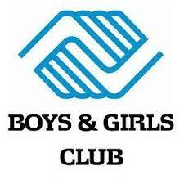
Boys & Girls Club (Alton Park Unit)
Address: 610 Lindsey St. Chattanooga, TN
Phone Number: 423-266-6131
Hours: Alton Park Unit
1154 W 40th St. Chattanooga, TN 37409

Boys & Girls Clubs of America is a national organization of local chapters which provide voluntary after-school programs for young people.

Boys & Girls Club (East Lake Unit)
Address: 2125 E 25th St. Place Chattanooga, TN 37404
Phone Number: 423-629-4943
Website: http://www.bgccha.org

Boys & Girls Clubs of America is a national organization of local chapters which provide voluntary after-school programs for young people.

Boys & Girls Club (Highland Park Unit)
Address: 2312 Duncan Ave. Chattanooga, TN 37404
Phone Number: 423-629-0008
Website: http://www.bgccha.org

Boys & Girls Clubs of America is a national organization of local chapters which provide voluntary after-school programs for young people.


Chattanooga Zoo at Warner Park
Address: 301 N Holtzclaw Ave. Chattanooga, TN 37404
Phone Number: 423-697-1322
Website: www.chattzoo.org
Hours: Everyday 9am – 5pm


Girls, Inc.
Address: 4505 Brainerd Rd. Suite 110 Chattanooga, TN 37411
Phone Number: 423-624-4757
Website: www.girlsincofchatt.org
Hours: Monday - Friday 9am – 5pm

In partnership with schools and at Girls Inc. centers, we focus on the development of the whole girl. She learns to value herself, take risks, and discover and develop her inherent strengths. The combination of long-lasting mentoring relationships, a pro-girl environment, and research-based programming equips girls to navigate gender, economic, and social barriers, and grow up healthy, educated, and independent. Informed by girls and their families, we also advocate for legislation and policies to increase opportunities and rights for all girls.


The Bethlehem Center
Address: 200 W 38th St. Chattanooga, TN 37410
Phone Number: 423-266-1384
Website: www.thebeth.org
Hours: Monday - Friday 8am – 6pm

We are God's people empowering inner-city youth and families to lead responsible lives by providing discipleship, education, and leadership development. We teach our program participants values like integrity and servant leadership which empower them to be the change they want to see in themselves, their families, their communities, and their city.


The Hamilton County Election Commission
Address: 700 River Terminal Rd. Chattanooga, TN 37406
Phone Number: 423-209-VOTE (8683)
Email: vote@hamiltonTN.gov
Website: http://elect.hamiltontn.gov/
Hours: Monday – Friday 8am – 4pm

Department of Youth & Family Development
Address: 501 W. 12th St. Chattanooga, TN 37402
Phone Number: (423) 643-6400
Hours: Monday – Friday 8am – 4:30pm
Website: http://www.chattanooga.gov/youthandfamily

The Department of Youth and Family Development's top priority is providing a better quality of life for the citizens of Chattanooga, through education, recreation, social services, and leadership. Chattanooga YFD offers a large variety of programs, activities, classes, and opportunities for youth, adults and seniors at numerous locations all across Chattanooga.

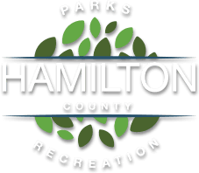
Hamilton County Parks and Recreation Department
Address: 2277 N. Gold Point Cir. Hixson, TN 37343
Phone Number: (423) 209-6899
Website: https://parks.hamiltontn.gov/
Hours: 8am – 4pm

Credit for resources for the Re-Entry Program Resource Guide given to:
City of Chattanooga Head Start and Early Head Start Resource Directory
https://chattanoogaheadstart.com/resources/
Step TN Treatment & Recovery Resource Guide
The 2019 Recovery Resource Guide from the Addictions and Dependency Committee of the Chattanooga Hamilton County Regional Health Council.
The Healthy Babies Resource Guide 2019
The Chattanooga Hamilton County Resource Guide for Domestic Violence Services
The United Way 211 Resource Guide
Chattanooga Endeavors Community Services Directory

Re-Entry Resource Directory made for the Re-Entry program by Social Counselor Laurie Gandre

